**The Bloggers**

You will have 4 essays due throughout the semester. The dates by which you MUST have these blogs on EDSBY are: February 18, March 10, April 14, and May 12.

In your blog, you must find information from several sources on a topic (see example topics below). Preferably, this topic will be one that is in the news, or should be, that covers an area of that you believe affects our society.

Topics:

bullying in schools; violence in local communities; accessibility of buildings in the local community for people with disabilities; availability of recreational facilities in the local community; casino development; voter turnout; issues related to freedom of information, taxation, water quality; Aboriginal treaty rights; the impact of consumer choices; human rights issues related to racism, child labour, the rights of girls or women, homophobia, or classism; intervention in foreign conflict

You must cover the following in your work:

A1.2 select and organize relevant evidence, data, and information on issues, events, and/or

developments of civic importance from a variety of sources

A1.3 assess the credibility of sources relevant to their investigations (e.g., the reliability of the evidence presented in a source; the purpose, intended audience, and context of a source; the bias, values, and expertise of the speaker/author) Sample questions: “Does this author back up

his or her position with specific evidence or data, or are the claims unsupported?” “What

criteria might you use to help you determine if a source is credible?” “Are there reasons to

think that this source might be biased in some way?” “What ideas are presented in this interview or news story? Do your other sources on this issue support these ideas? If not, which source do you think is the most reliable? Why?”

B1.1describe some civic issues of local, national, and/or global significance (e.g., bullying in schools; violence in local communities; accessibility of buildings in the local community for people with disabilities; availability of recreational facilities in the local community; casino development; voter turnout; issues related to freedom of information, taxation, water quality; Aboriginal treaty rights; the impact of consumer choices; human rights issues related to racism, child labour, the rights of girls or women, homophobia, or classism; intervention in foreign conflict), and compare the perspectives of different groups on selected issue

Grading:



Thinking:

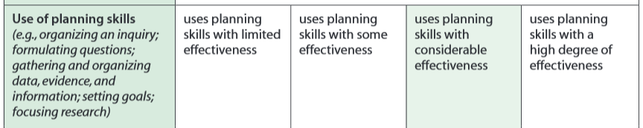

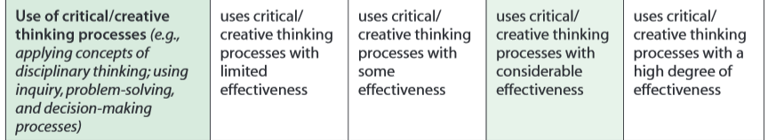

Communication:

