**Weekly Assignments**

The Civics Assignments is a collection of **CURRENT** articles and responses relating to assigned topics about our **CANADIAN** government.

How should each assignment be completed and when?

Each assignment must be ready by the beginning of classon Thursday.

What if I do not complete an assignment on time?

One day late = -1

More than one days late = -2

Where do I find articles/news?

***Stick to Canadian news***. The best place to look is in a newspaper like the Star, the Globe & Mail, or the National Post. If you want to watch something, make sure that the story presented is significant. You can also look online- a good place to check out is the CBC's website, or a newspaper's website. You may even watch the news on TV to find good information. Make sure the TV news is significant. For example, “the National” does stories that are usually 5-10 minutes long that cover topics in detail.

Online Papers: [www.thestar.com](http://www.thestar.com/) ; [www.theglobeandmail.com](http://www.theglobeandmail.com/) ; <http://www.nationalpost.com/> ; OR watch The National on CBC at 11:00pm. It's also online <http://www.cbc.ca/thenational/>or [www.cp24.com](http://www.cp24.com/)

How are these assignments marked?

Each assignment is marked out of **ten** points. One point is given for the neatness of the paragraph responses, one points are given for the proper MLA source, four points are given for the summary and four points are given for a thoughtful response. Points will be deducted if grammar, spelling, or punctuation gets in the way of communication.

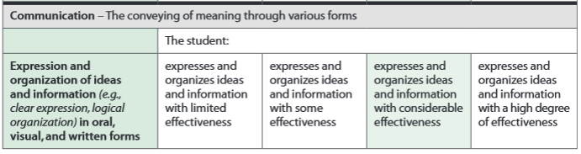

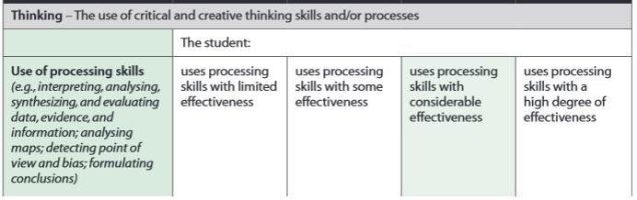

**Due Dates:** **Due Dates:** Feb. 18, 25; Mar. 3, 10, 24, 31; Apr. 7, 14, 21, 28; May 5, 12, 19, 26, June 2.

Description of READING/WATCHING THE CANADIAN GOVERNMENT NEWS Assignment:

Find a current events article that affects any of the topics listed below. Respond with a two paragraph response. Start by summarizing the article. Then respond with some of the following:

assess the credibility of sources relevant to their investigations (e.g., the reliability of the evidence presented in a source; the purpose, intended audience, and context of a source; the bias, values, and expertise of the speaker/author) Sample questions: “Does this author back up his or her position with specific evidence or data, or are the claims nsupported?” “What criteria might you use to help you determine if a source is credible?” “Are there reasons to think that this source might be biased in some way?” “What ideas are presented in this interview or news story?

Acceptable topics: Anything government related. This should be CANADIAN content however. You may, however, also report and learn about any crisis or political happenings you read about in other countries (but do NOT cover American politics).

Remember the purposes of this assignment when selecting an article:

 Be aware of current political events in Canada (and the world)

 READ the newspaper (online papers are good too)

 If you question whether something is government related, think about our government walk that we did in the beginning of the semester