**Weekly Assignments**

The Civics Assignments is a collection of **CURRENT** articles and responses relating to assigned topics about our **CANADIAN** government.

How should each assignment be completed and when?

Each assignment must include the name and date of the source it was taken from. Assignments must be completed neatly and accurately and either handed in or submitted through internet assignments on EDSBY by the beginning of classon Thursday **(3:00 if it is not a school day)**, regardless if we have class/school that day or not.

What if I do not complete an assignment on time?

One day late = -1

More than one days late = -2

Section 1: Weeks 1 – 5: WATCHING THE NEWS

How are these assignments marked?

Each assignment is marked out of **ten** points. 10/10 is reserved for assignments that are very well done and completed FULLY. Descriptions must be clear. (You may not watch celebrity news for this assignment). The Sheet is on EDSBY entitled “Watching the News”.

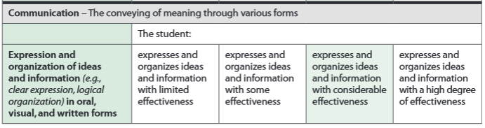

Suggested Sources:

CBC News, CTV News, other Canadian news stations

Online source: CP24: <http://www.cp24.com/>

How do I show my sources for section 1?

**On the TV:** CTV News. CTV. Toronto, ON. Feb. 1, 2011. Television.

Name of Show. TV Station. City, Province. Date Aired. Television.

**Online:**  CP 24. Toronto, ON, 1 Feb. 2011. Web. 1 Feb. 2011. <http://www.cp24.com/>.

Name of Show. City, Province. Date. Date Watched. <website>

**Due Dates:** Feb. 18, 25; Mar. 3, 10, 24.

Section 2: Weeks 6 – 15: READING THE CANADIAN

GOVERNMENT NEWS

Where do I find articles/news?

***Stick to Canadian news***. The best place to look is in a newspaper like the Star, the Globe & Mail, or the National Post. You can also look online- a good place to check out is the CBC's website, or a newspaper's website. You may even watch the news on TV to find good information.

Online Papers: [www.thestar.com](http://www.thestar.com/) ; [www.theglobeandmail.com](http://www.theglobeandmail.com/) ; <http://www.nationalpost.com/> ; OR watch The National on CBC at 11:00pm. It's also online <http://www.cbc.ca/thenational/>or [www.cp24.com](http://www.cp24.com/)

How are these assignments marked?

Each assignment is marked out of **ten** points. One point is given for the neatness of the paragraph responses, one points are given for the proper MLA source, four points are given for the summary and four points are given for a thoughtful response. Points will be deducted if grammar, spelling, or punctuation gets in the way of communication.



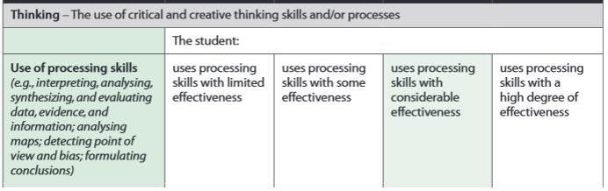

How do I show my sources?

Assignments need **proper MLA style sources**. The best way to do this is to use the KnightCite service found at [www.calvin.edu/library/knightcite/](http://www.calvin.edu/library/knightcite/)

Proper source: **Internet**

“Article Title”, website. Date Visited: (date you went to the site).

“Man was pepper-sprayed previously, inquest told,” <http://www.thestar.com/printArticle/291907>Date Visited: January 9, 2008.

Proper source: **From Newspaper**

“Article Title”, Newspaper Name. Date Published, Section: Page Number of Article.

“Man was pepper-sprayed previously, inquest told,” World & Comments: Page 4.

**Due Dates:** Mar. 31; Apr. 7, 14, 21, 28; May 5, 12, 19, 26; June 2.

Description of READING THE CANADIAN GOVERNMENT NEWS Assignment:

Find a current events article that affects any of the topics listed below. Write a two paragraph response. In the first paragraph summarize the article. In the second paragraph state your opinion, do you agree? Why or why not? Each paragraph should be a minimum of five sentences long.

The articles MUST be submitted within one week of the publishing date. Do not find old articles; always use current news.

Acceptable topics: Anything government related. This should be CANADIAN content however. You may, however, also report and learn about any crisis or political happenings you read about in other countries (but do NOT cover American politics).

Remember the purposes of this assignment when selecting an article:

 Be aware of current political events in Canada (and the world)

 READ the newspaper (online papers are good too)

 If you question whether something is government related, think about our government walk that we did in the beginning of the semester