Here is the front page of the exam.

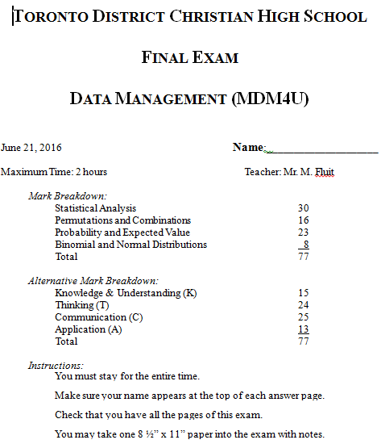

What to expect on the exam. Expect to know the terms from the first two units. Be able to apply terms like standard deviation and know what it means. You should be able to calculate the MMM’s and range by hand. The technical math skills from the first two units will mostly be covered in the spreadsheet portion (take home) of the exam.

Permutations, Combinatorics, Probability, and Probability Distributions will be much like you saw on tests. Your best preparation would be to study your tests and fix-up mistakes. Try to recognize types of problems. Don’t forget about a couple of the “odd” topics – Binomial Expansion, and Pascal’s Triangle.

You will be provided with a Z-score chart, and you fill up the BACK SIDE of that paper with information that you think is helpful for your exam.