Unit 4: Permutations & Organized Counting
Day | Section/Topic | Daily Plan, Homework & Reading/Glossary assignments
Day 1 | 4.1  Organized Counting | - Review of Prerequisite Skills: Optional: Page 224 #2, 3a-c, 4ab, 5-6 (a & b only), 7.  - Combinatorics: counting in complex situations (ex: Licence Plates)  - Mutually exclusive events: multiplicative & additive counting principles  mxn ways to choose one item of each type; m+n ways to choose one item  - Making tree diagrams for counting  Read/Glossary: Page 225-228. Homework: Tree Diagrams (backside of outline) and P. 229 #1-4, 8, 9, 12, 13, 14, 15, 18b, 23.
Day 2/3 | 4.2  Factorials & Permutations | - Investigation: Choosing a President and V.P. from a group of people.  - Factorial! Permutations: nPr or P(n, r) = n!/(n-r)! Extension: (-7)!, 0!  - Factorials worksheet  - Graphing Calculator: MATH PRB menu  - Define: Iterative Process  Glossary: Permutation & Factorial. Handout “Permutation/Factorial Questions” and Homework: P. 239 #2-16 (even only), 19
Day 3/4 | 4.3  Permutations with some identical items | - Investigating permutations like “bookkeeper” & “referee”  - Flag/Map Colouring  - Permutations worksheet  Glossary: Key concept on P. 244. Homework: Flag Colouring Worksheet and P. 245 #1-2, 4, 6, 10, 12, 16.
Day 5 | 4.4  Pascal’s Triangle | - Investigation: Find as many patterns as you can in Pascal’s triangle.  - http://mathforum.org/dr.math/faq/faq.pascal.triangle.html  Start at “Probability”  - http://mathforum.org/workshops/usi/pascal/mo.pascal.html  Read through all of it and take notes.  - http://www.csam.montclair.edu/~kazimir/patterns.html  Read “The Chinese Knew About It”  - http://www.mathsisfun.com/pascals-triangle.html  Glossary: Identify all major patterns of Pascal’s Triangle. (More in Chapter 5)  Homework: P. 251-252 #3 (a&b only), 5 (add to glossary),11.
Day 6 | 4.5  Application: Pascal’s Triangle | - Bucket problem–Water is poured into the top bucket of a triangular stack of 2-L buckets. When each bucket is full, the water overflows equally on both sides in the two buckets below. (Page 259 #17).  - Assignment: Solving problems using Pascal’s Triangle  - http://www.probability.ca/jeff/java/buckets.html  Homework: P. 256-258 #2ac, 4a, 6, 8a, 10. Extension: 16 & 18.
Day 7 | Test: Unit 4 | - Review for Test: Page 260: 1 – 3, 6 – 9, 11 - 15 (Key Concepts) &  Page 261: 1 – 6, 8ab (Chapter Test)
 | Technology Applications | - http://www.brocku.ca/cmt/mdm4u/  - Text-book resources: www.mcgrawhill.ca/links/mdm12
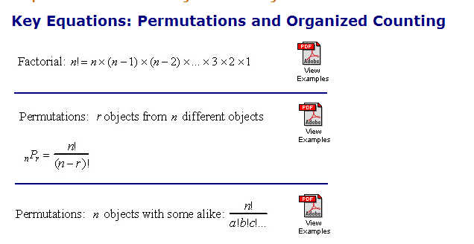

a) For #1-3, list all the possibilities.
b) For #1-4, make a Tree Diagram to represent all of the possible choices.

1. You Flip a coin 2 times.

2. You roll a dice 2 times.

3. You flip a coin and then roll a dice.

4. You make a sandwich using:
- Whole wheat, honey oat, or white bread
- ham or chicken
- with or without Mayonnaise
- with or without mustard.

5. You play a best of 3 series of Rock, Paper, Scissors between you and your friend. You record the winner on each round.

