Terms Used to Describe Data

- Qualitative Data: “Soft” Data. It's observed and based on your senses.
Ex. Colors, textures, smells, tastes, appearance, beauty, etc.

Quantitative Data: “Hard” Data. It's measurable.
Ex. Length, height, area, volume, weight, speed, time, temperature, humidity, sound levels, cost, members, ages, etc.

“Qualitative Data describes whereas Quantitative Data defines.”
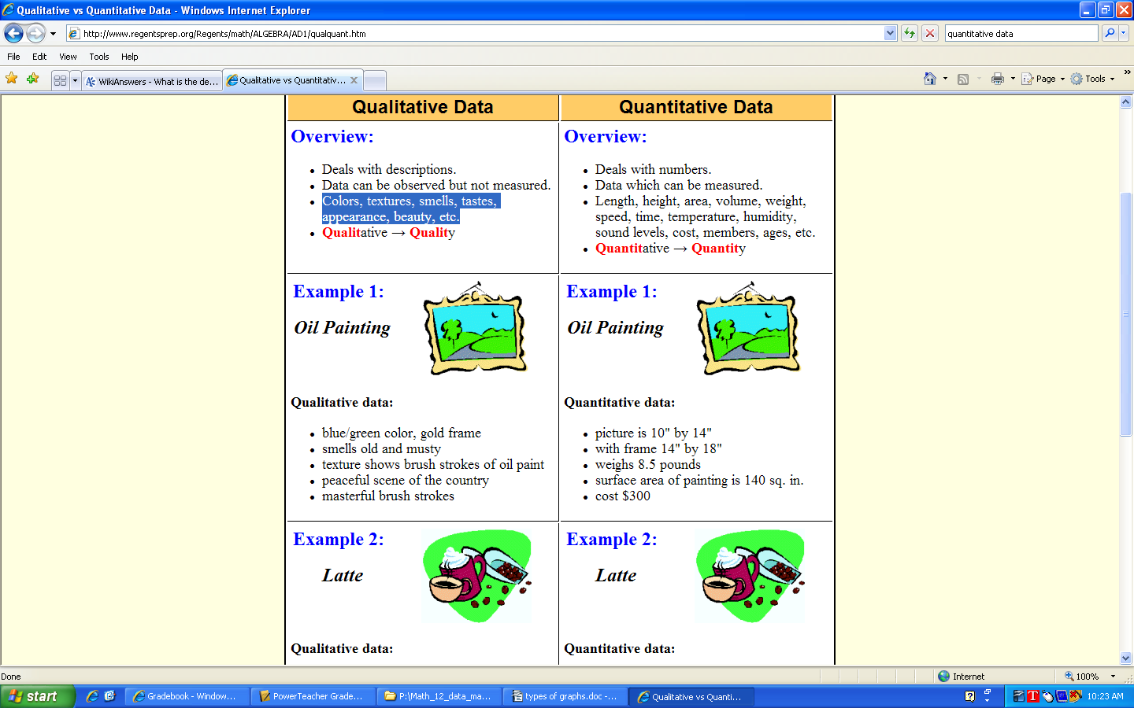
- Microdata: In a survey, it's information about the individuals response

Aggregate Data: Data collected and reported as the sum

- Primary Data:

Secondary Data:

- Experimental vs. Observational Studies

Types of Graphs: Find examples of each of these graphs.

- Pie Graph (Circle graph). Use when the data is converted to a percent (adds to 100). When comparing data, you need 2 pie graphs. Pie graph shows one variable only.

- a) Bar Graph—uses discrete data. The bars do not actually touch—they are used to graph discrete variables (data distinct; it does not change gradually). Ex: Favourite type of pizza.

Define discrete data: ___________________________________________________________

2. b) Histogram—uses continuous data. The bars touch, because the data changes on consistent intervals. Ex: marks on an exam, monthly precipitation amounts, frequency graphs (below).

Define continuous data: _________________________________________________________

- Line graph. Also used with continuous variables—usually used when 3 or more different variables are shown in one graph or when one variable has regular changes (stock market)

- Frequency Graph (from frequency table): Data intervals on the x-axis; frequency on the y-axis. Can be represented with Bar, Histogram, Line. Used with large data sets to show general trend

- Scatter plot. (think x-y Cartesian Graph). Only used when you have two variables that can always be paired in points A(x,y). Graphed as individual points; show a line of best fit. Find equation of that line. Ex: Average score over a two week period. Ex: height compared to weight.

- Box plots (sometimes called box-whisker diagrams). Used with percentile data or extremely large data sets. Breaks all data down into four quartiles and visually shows the range of each.

- Combination graphs (or 3-D graphs). Use with caution.

- Stem-and-leaf plots. Statisticians who are stuck in the 1980's (some of your future profs) still use these. Most discarded this graph with the typewriter. Good for large quantitative data sets.

Draw sketches below for your studying purposes, or save examples to the P: drive. You are not responsible for #7 & 8.

