NAME: ____________________________ DATE: ____________________________

Investigation: Can you Tell the Height from a Bone?

Anthropologists can estimate a person’s height from their skeletal remains by examining the length of their radius bone. A strong positive correlation exists between human height and the length of the radius bone for most adults. Does this relationship hold for youth as well?

- Measure the length of your radius bone, and height, in centimetres.

Length of radius bone: ___________ cm Your height: ___________ cm

- Based on your data, can you predict the height of other people if you measure their radius bone? Why or why not?

- Use data from your classmates. Create a scatter-plot.

- What is the correlation (r-value)? What does this mean? r = ___________

- What is the Linear Regression Equation? ________________________________________

- Create a scatter-plot (using the grid below) to graphically represent your results. Be sure to label the x & y axis and draw a linear regression equation. Paste the scatter-plot below.

Extension:

Suppose you are hired as an anthropologist’s assistant. You are given three different radius bones whose lengths are 26 cm, 30 cm, and 35 cm. Your task is to determine the height of the adults to whom these bones belonged. Use the data below and the linear regression equation to determine the height of the adults to whom these bones belonged. Graph the results on the grid below.
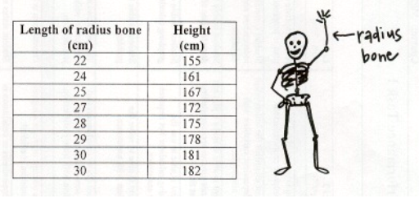

Linear Regression Equation: ________________________________; Correlation: r = _____________

Height of the 3 people: 1) 26 cm _____________, 2) 30 cm _____________, 3) 35 cm _____________

