**Section 2.1**

#1, 2, 3, 5, 7, 14

1. Simplify by collecting like terms.

|  |  |
| --- | --- |
| a) | b) |
| c) | d) |

2. Expand and simplify.

|  |  |
| --- | --- |
|  |  |
|  |  |

3. Expand and simplify.

|  |  |
| --- | --- |
|  |  |
|  |  |

5. Expand and simplify.

|  |  |
| --- | --- |
|  |  |
|  |  |

7. Expand and simplify.

|  |  |
| --- | --- |
|  |  |

14. Expand and simplify.

|  |  |
| --- | --- |
|  |  |
|  |  |

**Section 2.2**

#3, 6, 15, 19 (tricky, try it out)

3. Factor, using the greatest common factor.

|  |  |
| --- | --- |
|  |  |
|  |  |

6. Factor.

|  |  |
| --- | --- |
|  |  |
|  |  |
|  |  |

15. Factor.

|  |  |
| --- | --- |
|  |  |
|  |  |

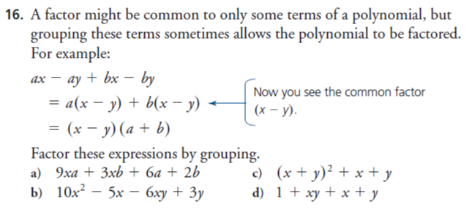

**Section 2.3**

#3, 6, 9, (14 if you want a challenge)

3. Factor

|  |  |
| --- | --- |
|  |  |
|  |  |

6. Factor

|  |  |
| --- | --- |
|  |  |
|  |  |

9. Factor

|  |  |
| --- | --- |
|  |  |
|  |  |
|  |  |

14. Factor

|  |  |
| --- | --- |
|  |  |
|  |  |

**Section 2.4**

#4, 5, 9, (13 if you want a challenge)

4. Factor. You may first need to determine a common factor.

|  |  |
| --- | --- |
|  |  |
|  |  |
|  |  |

5. Factor

|  |  |
| --- | --- |
|  |  |
|  |  |
|  |  |

9. Factor

|  |  |
| --- | --- |
|  |  |
|  |  |
|  |  |

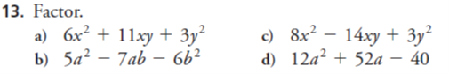

**Section 2.5**

#2, 3, 4, 11

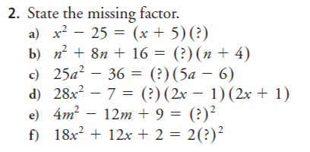

3. Factor.





4. Factor, if possible.

|  |  |
| --- | --- |
|  |  |
|  |  |
|  |  |

11. Factor

|  |  |
| --- | --- |
|  |  |
|  |  |