**MultiMath Chapter 3: Properties of Quadratics Name:___________________________**

**Section 3.1**

1. State the direction of opening, the y-intercept, the zeros, the AoS, the max/min value and the vertex.

|  |  |
| --- | --- |
|  |  |
|  |  |
|  |  |

2. Graph the given properties, then sketch the parabola.

|  |  |
| --- | --- |
| a) Zeros at $x=-2$, $x=4.$ Vertex at $\left(1,4\right).$ | b) Vertex $\left(3,-5\right)$ and y-intercept at $\left(0,-2\right).$ |
| c) Max value of 5, AoS at $x=-4,$ and point $\left(-3,-3\right)$ | d) Zeros at $x=6$ and $x=2$ and opens up. |
| e) No zeros, vertex at $\left(-5,-1\right).$ | f) One zero at $x=1$, AoS at $x=3,$ and opens down. |

**Section 3.2**

1. Convert from Factored Form to Standard Form, then state the y-intercept.

a) b)

c) d)

2. Given the x-intercepts, determine the Axis of Symmetry.

a) $x=5$ and $x=9$ b) $x=-16$ and $x=-24$

c) $x=-2$ and d) and

3. Given the equation and the Axis of Symmetry, calculate the max/min value (and indicate whether it is a maximum or minimum).

a) $y=x^{2}-4x+7$ with $AoS=2$ b) $y={-2x}^{2}-20x-51$ with $AoS=-5$

c) $y=\frac{-1}{2}x^{2}+4x-7$ with d) with

4. Given the equation in Standard Form, do the following:

1. Convert to Factored Form by, well, factoring…  
 2. State the zeros (remember opposite).  
 3. Use the zeros to calculate the Axis of Symmetry.  
 4. Use the AoS to calculate the max/min value (and whether it is a maximum or minimum).  
 5. State the vertex.

a) $y=x^{2}-4x-32$

b) $y=x^{2}+7x+12$

c) $y=7x^{2}-98x+280$

d)

e)

f)

**Section 3.3**

1. Convert Vertex Form the Standard Form by expanding. Careful with the perfect square.

a) $y=3{(x+2)}^{2}+9$ b) $y=-5{\left(x-6\right)}^{2}+10$

c) d)

e) f)

g) h)

2. Go back to Section 3.2 #4. For each question that you did, fill in the *a* and vertex, then write the Vertex Form.

|  |  |
| --- | --- |
| a) *a =*  Vertex =    Vertex Form is y = | b) *a =*  Vertex =    Vertex Form is y = |
| c) *a =*  Vertex =    Vertex Form is y = | d) *a =*  Vertex =    Vertex Form is y = |
| e) *a =*  Vertex =    Vertex Form is y = | f) *a =*  Vertex =    Vertex Form is y = |

3. Graph the quadratic by creating a table of values with the vertex in the middle, the two points on either side.

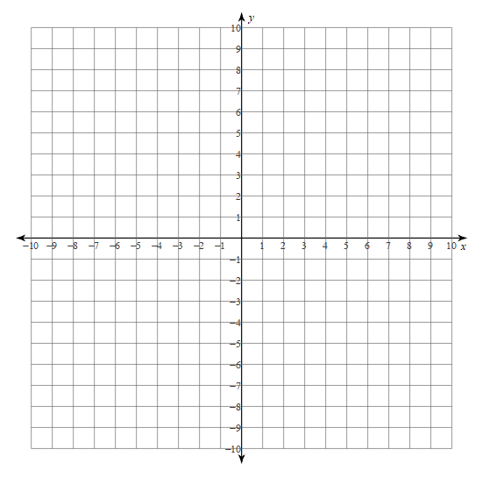a) $y=3{(x-4)}^{2}-8$

b) $y=-2{\left(x+3\right)}^{2}+4$



c) $y=0.5{(x+6)}^{2}-3$

d) $y={2(x-3)}^{2}+4$

**Section 3.4**

1. Given the following parabolas, state the vertex and one other point. Then, starting with the basic Vertex Form, plug in the point and the vertex, then solve for ***a***. Finish by stating the equation of the parabola.

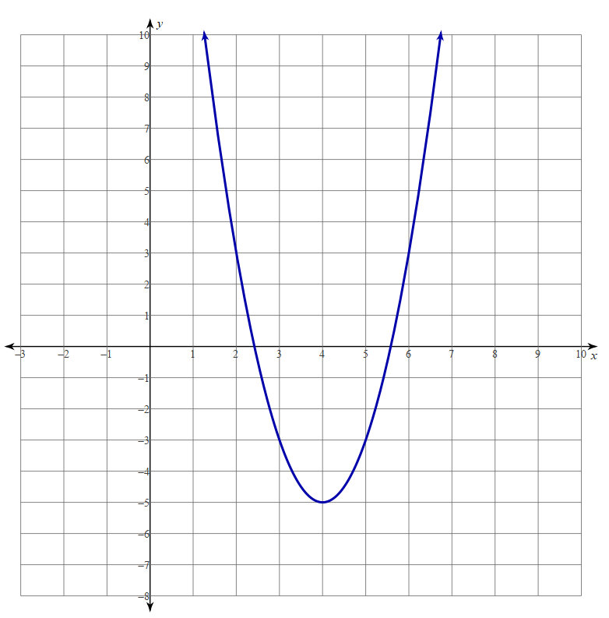a) Vertex is: Point is:

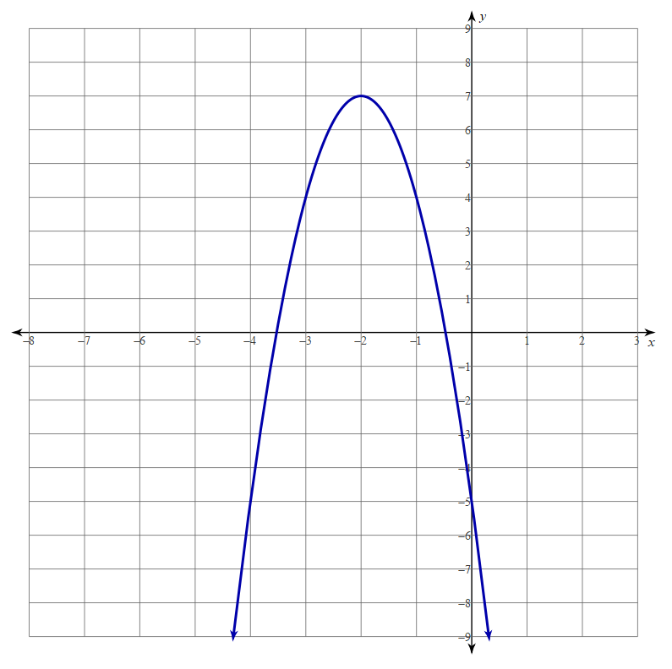b) Vertex is: Point is:

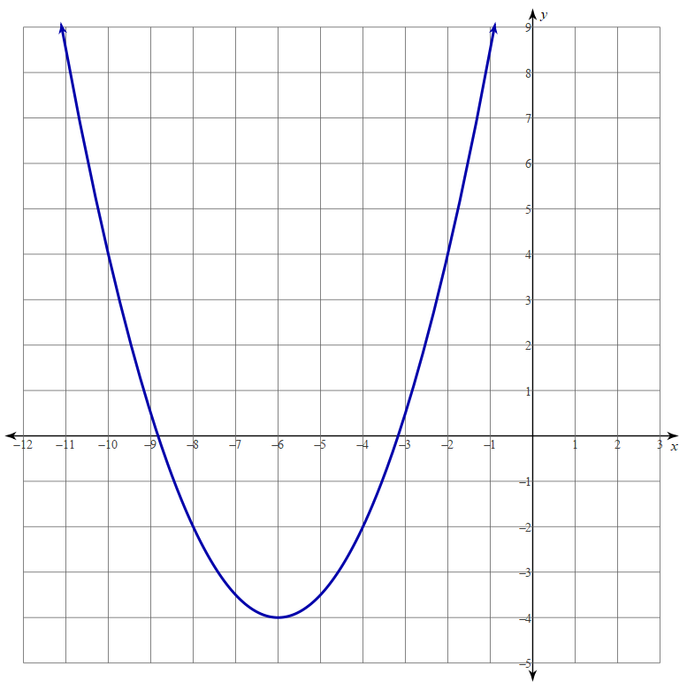

c) Vertex is: Point is:

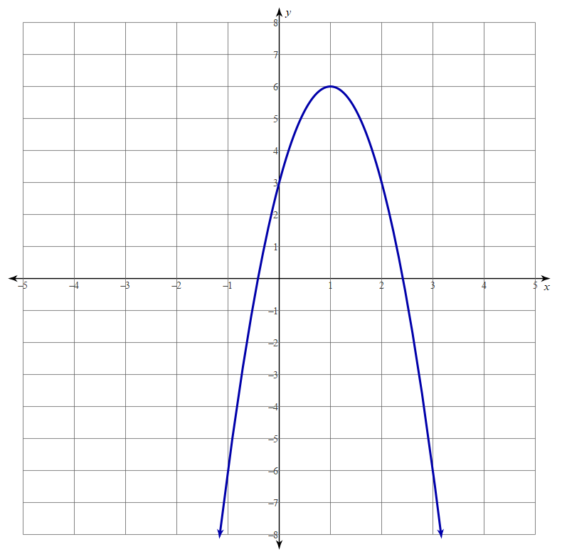d) Vertex is: Point is:

2. Given the following parabolas, state the zeros and one other point. Then, starting with the basic Factored Form, plug in the point and the zeros, then solve for ***a***. Finish by stating the equation of the parabola.

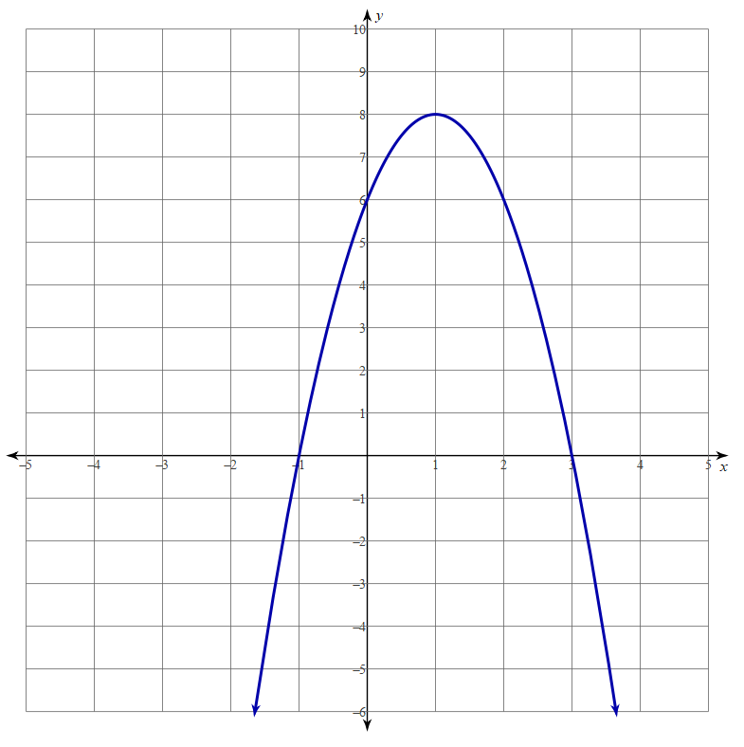a) Zeros are: Point is:

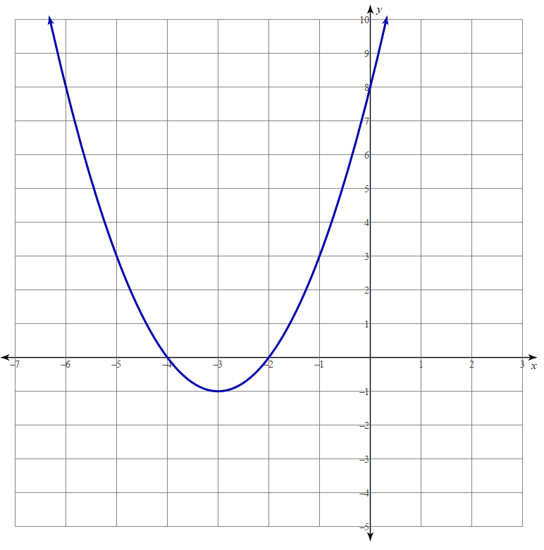b) Zeros are: Point is:

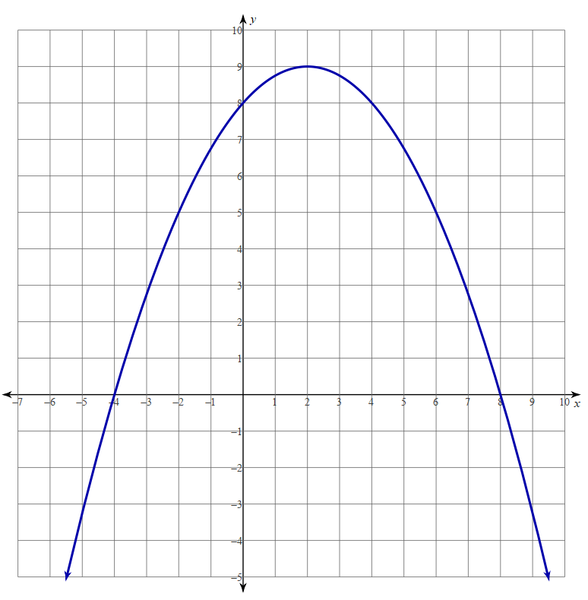c) Zeros are: Point is:

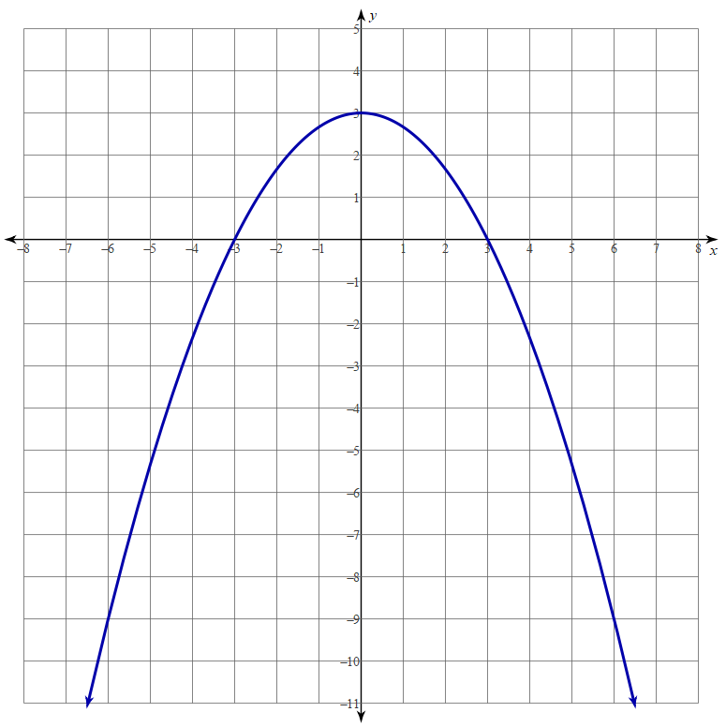

d) Zeros are: Point is:

3. A certain parabola has an *AoS* of 6, a maximum value of 20, and a y-intercept of -160. Determine the parabola in Vertex Form.