**5.1: Similar Triangles**

**Learning Goal:** We are learning the properties of similar triangles.

Two triangles are “**similar**” if they meet two conditions:

* All of their corresponding angles must be ________________________________
  + You only need to check that two are identical. Why?
  + Be careful to consider that the triangles might be rotated!
* All three of the pairs of sides must be in _________________________________
  + “In proportion” means that there is some common factor that you can multiply one side length by to get another.

All of the following are examples of similar triangles

|  |  |
| --- | --- |
|  | Image result for similar triangles |
|  |  |

**What is the height of the tree?**

To solve for the height, you must set up a **proportion**

Make sure that what you are trying to find is in the numerator!

Solve for the missing value by _______________________________________

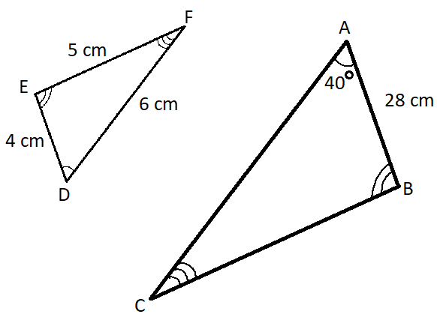**Example 1: On the triangles to the right….**

List all three pairs of corresponding angles.

What is the size of angle D?

What is the length of side b?

What is the length of side a?

**Example 2:**

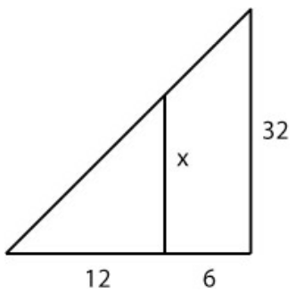How do you know the triangles to the right are similar?

What scale factor exists between the two triangles?

What is the size of side x?

**Success Criteria**

* I can test if two triangles are similar by
  + Seeing if their angles are identical
  + Checking that all three sides are proportional
* I can solve for an unknown side length in two similar triangles
* I can solve for an unknown angle in two similar triangles