**5.3: SOHCAHTOA**

**Learning Goal:** We are learning to use SOHCAHTOA to solve problems involving right triangles.

**SOHCAHTOA** is a handy acronym to help us remember the relationships between an angle and two side lengths.

S = ________________________________

O = ________________________________

H = ________________________________

C = ________________________________

A = ________________________________

H = ________________________________

T = ________________________________

O = ________________________________

A = ________________________________

Label The sides of the following triangles for angle X

**Adjacent, Opposite, Hypotenuse**. You may use A, O and H to stand for the full word.

x

x

A

Fill in the blanks:

a) In ABC, the hypotenuse is _______,

the opposite to C is _______,

the adjacent to A is _______,

C

B

D

b) In EDF, e is the ________________________ or DF

d is the ________________________,

and f is the _________________________.

x

F

E

Sin R=

P

13

Cos R=

5

R

12

Tan R=

Finding the ratios is useful, but what if we want to know the size of angle R? Well, once we know our trig ratios (*sin, cos, tan*) we can use ANY of them to find out the size of R! Just use the inverse operation technique we learnt yesterday!

What is the size of angle R? Calculate it using all three ratios.

Bonus: What is the size of angle P – without using trig ratios….

**Angle Of Elevation**

When you see an object ___________ you there is an _______________________________________

between the horizontal and your ________________________________________________.

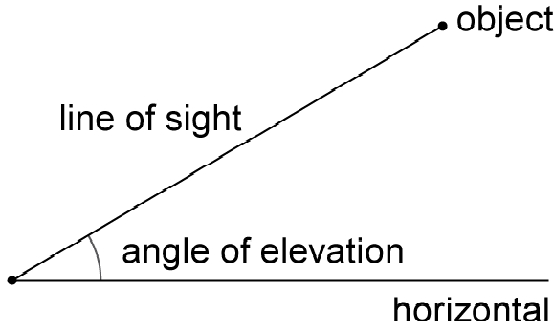

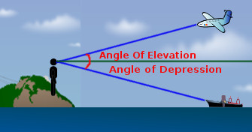

Let’s Practise

The angle of elevation of the top of a tree is 30o from a point 28 ft away from the foot of the tree. Find the height of the tree rounded to the nearest foot.

**Angle Of Depression**

When you see an object ______________ you there is an ____________________________________

between the horizontal and your ________________________________________________.

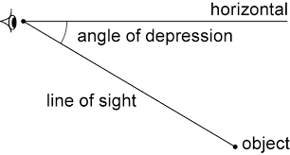

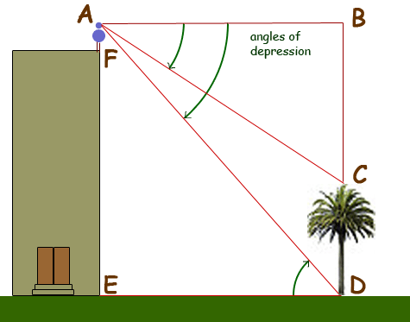

Let’s Practise

A great white shark swims 22ft below sea level. If the shark is 67.7 feet from the sailboat, what is the angle of depression of the boat to the shark?

**Other Examples**

|  |  |
| --- | --- |
| What is the size of angle B?  Image result for solve the right triangle | What is the size of angle Z? |
| What is the size of angle x?  Image result for solve the right triangle | What is the length of side y. *Hint – don’t use trig ratios!* |

**Success Criteria**

* I can use SOHCAHTOA to solve for a missing side length or angle in a right angle triangle