
K: ___ T: ____ C: _____ A: _____
22 4 2 14

Functions 11 – U3 Test: Quadratic Functions Name: _____________________

1. Given the function $f\left(x\right)=-2x^{2}+8x-1$ ___ 4K
a) State the y-intercept.

b) State the direction of opening for the parabola.

c) Determine the vertex for the parabola using any technique you wish.

2. Sketch the graph of $f\left(x\right)=(x-2)(x+4)$ ___6K

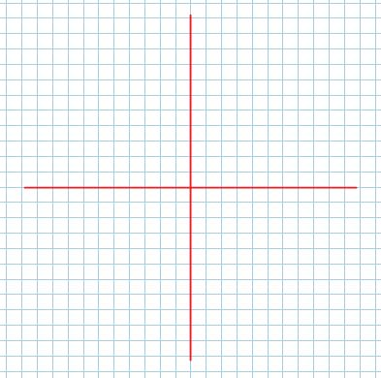
Label the vertex, the zeros, the y-intercept and its symmetric partner and the axis of symmetry.

3. Express each answer in simplified radical form:
a) $2\sqrt{18}-4\sqrt{50}$ ___ 3K b) $\left(1+2\sqrt{5}\right)\left(3+2\sqrt{10}\right)$ ___ 3K

4. A company’s profit can be determined by the function, $p(x)=-4x^{2}+24x-18$, where x is the number of units sold, in hundreds, and p(x) is the profit in thousands of dollars. How many units need to be sold to maximize their profit and what is their maximum profit? ____ 4A

5. A diver makes a perfect dive from a $10m$ high platform. The height of the diver above the water can be modelled by the equation $h\left(t\right)=-5t^{2}+t+10$. Determine how long the diver is in the air. ____ 4A

6. Determine how many zeros are in the function:
a) $f(x)=-4x^{2}+5x-3$ b) a quadratic with a minimum value of $-2$. ____4T

7. Determine the solutions to the equations, by factoring if possible, or the quadratic formula. ___6K

a) $3x^{2}-4x=4$ b) $4x^{2}+3x-2=0$

8. Determine the point(s) of intersection of the functions $f(x)=-4x+7$ and $g(x)=3x^{2}-19x-65$. ___6A

