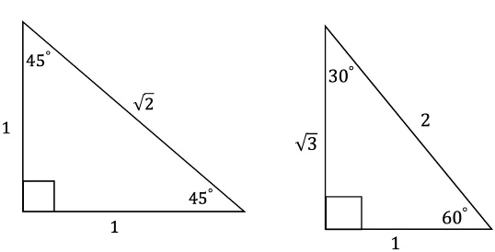
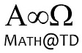
MCR3U

Name__________________________

Unit 5 – Trigonometric Functions
Quiz (The Real Deal): Angles of Rotation, Trig Ratios and Special Triangles (No Calculators!!)

- Draw the Angle of Rotation. Determine the Related Acute Angle. Determine the trig ratios exactly (using SOH CAH TOA and CAST) (K1 point each)
- $\tan\left({210}^{∘}\right)$ b) $\sin\left({315}^{∘}\right)$

$\text{ c)}$ $\cos\left({300}^{∘}\right)$ d) $\sec\left({120}^{∘}\right)$

e) $\sin\left(-{120}^{∘}\right)$

- For $0^{∘}≤θ≤360^{∘}$ , determine the angles of rotation given the trig ratio: (T2 points each)

- $\sin\left(θ\right)=\frac{\sqrt{3}}{2}$ b) $\cos\left(θ\right)=-\frac{1}{\sqrt{2}}$

c) $\tan\left(θ\right)=-\sqrt{3}$

