
MCR3U

Functions 11 (P3) – Project Day: Transformations Assignment
Learning Goals
- We are learning to recognize combinations of function transformations and how they affect the sketch of a parent function’s graph
- We are learning how to use GeoGebra to visually explore transformations

You will be creating a GeoGebra Applet which demonstrates Function Transformations. You will be handing in your final construction (as a “ggb” file – to be explained later)


- You will need a GeoGebra account to save your work (so that you can hand it in). If you have an account already, skip to 2. If you do not have a GeoGebra account, navigate to www.geogebra.org.
  - Click on “Sign In” (top right of the page)
  - Click on “Create Account” and go through the process.

- Sign in to your account and go to the Graphing Calculator (you can click on “Start Graphing”)

- The GeoGebra graphing app has three panels: An Input/Tools panel, a Graphics panel, and a software keyboard panel (not needed unless you are on a tablet ot phone).
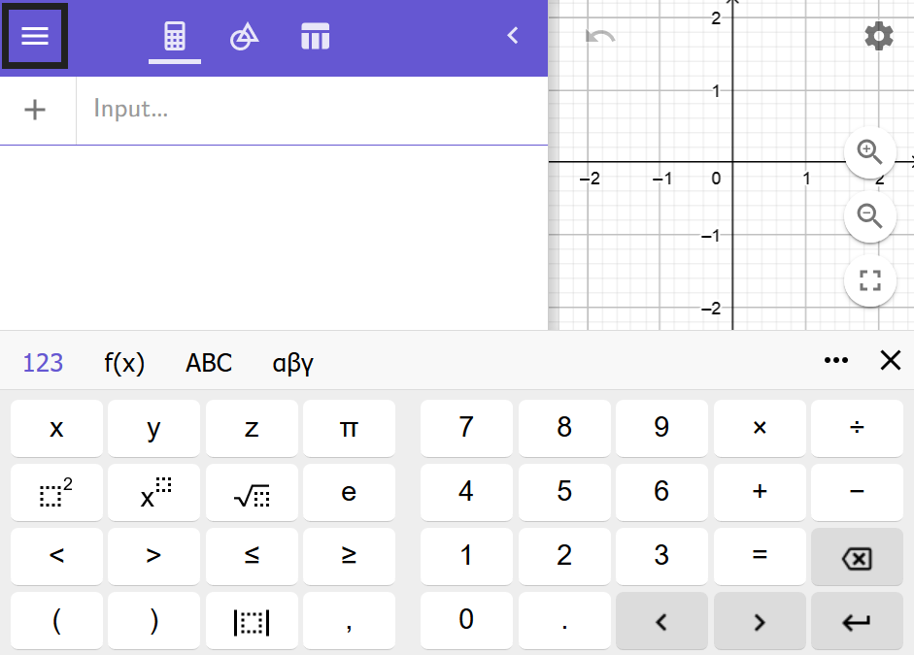

- In the Input Panel, type one letter – “x” – and then hit “ENTER”.
Two things happened: First, GeoGebra named your “x”, “$f\left(x\right)=x$”. Thanks GeoGebra! Second, GeoGebra plotted a sketch of $f\left(x\right)=x$.

You are now ready to begin to construct your GeoGebra Transformer.

Our goal is to understand function transformations. Consider some Parent Function $f(x)$. We can Transform our parent function and construct a new function though the “transformational equation”

$$g\left(x\right)=a⋅f\left(k\left(x-d\right)\right)+c$$

We could just ask GeoGebra to sketch a transformed function, but GeoGebra can do SO MUCH MORE if we treat the transformation numbers $\left\{a,c,k,d\right\}$ as if they are variables (they aren’t! – we call these kinds of numbers parameters). If you don’t have “f(x)=x” in your first input box, type “x” (no quotes) and hit “Enter”.


GeoGebra deals with parameters beautifully with one of the built in “Tools” – Sliders! Tools are found in the “Tools Panel”. Click on the icon indicated.

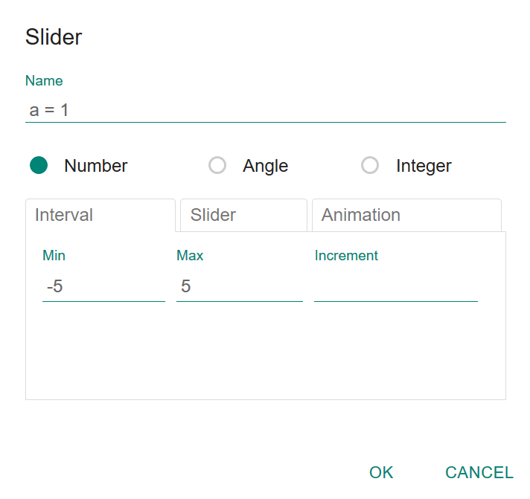
Next, click on “Slider” and then click on the graphics panel in some empty spot (note that you will need 4 sliders in total because you have 4 parameters, so make sure you have enough room). After clicking on an empty spot you will see a pop-up

This is good for parameter “a”, so click OK

Make three more sliders, but make sure one is named “k”, one “d” and one “c” (you can change the default name)

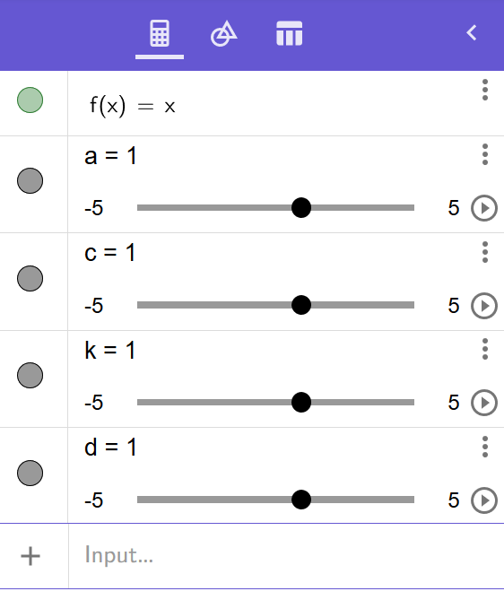
Your input panel should now look like this:
(click on the “Algebra” Icon to get back to the input panel)

Now you are ready to construct your transformed function. In the next empty input box type
a*f(k(x-d))+c
and hit enter. GeoGebra will give the new function name (probably $g(x)$).

Play with the sliders.

OK – transforming a linear function is boring.
Now you could type a new parent function where ‘f’ is, (please don’t) but we will go for (voice change to something sounding deep and foreboding) the power.

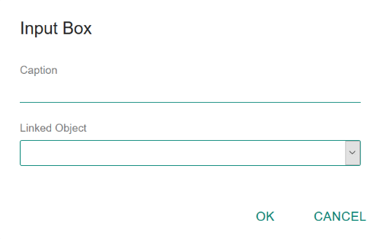
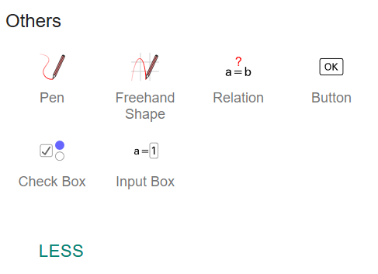
We will use an “Input Box” (one of the GeoGebra Tools). Click on the Tools icon and scroll to the bottom of the panel. Click on “MORE”. The bottom of the input panel will now look like this: (without all the writing)

You now can type ANY parent function into your input box. GeoGebra will plot your Parent Function, and your Transformed Function. You can use the sliders to manipulate your transformed function. And now for some questions:

Name ______________________

Functions 11 (P3) – Project Day: Transformations Assignment Questions

Please hand these pages in on Tuesday March 5 at the beginning of class.

Your Sliders for a and k are both “stretches”. Both sliders can go from $-5$ to $5$. That is, both a and k can be negative. That is how GeoGebra will show FLIPS (if the stretch numbers are negative, we have a flip (reflection around an axis)).

In your input box type “x^2” (if you are using a traditional keyboard). If you are using the software keyboard click on “x” and then click on $"{}^{2}$”. In either case hit enter after typing x^2.

Q1) Put your sliders at $a=-1, c=1, d=-2, k=2$. Explain in detail, using the language of transformations, the differences between the Parent Function $f\left(x\right)=x^{2}$ and the transformed function $g\left(x\right)$.

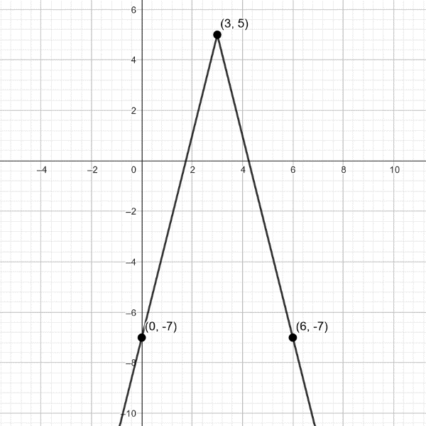
Q2) Put your sliders at $a=1, c=0, d=0, k=-1.$ Change the parent function to $f\left(x\right)=|x|$ (hit enter after changing the function). How does $k=-1$ affect the parent function. Why?

Consider the sketch of a transformed absolute value function, $g(x)$, to the right. Determine the equation of $g(x)$ using what you know about transformations. Note: k=1 for this function (finding “a” will be the toughest part)

Q3) Change the parent function to $f\left(x\right)=\sqrt{x}$ (hit enter!). Use the sliders to show a transformed square root function with the following transformations applied:

Vertical Stretch by 3, Vertical Shift Down 2
Horizontal Flip, Horizontal Shift Right 3

What is the equation of your transformed function? (hint – look in your input panel)

What is the domain and range of the parent function?

What is the domain and range of the transformed function? (use the GeoGebra graph!) What is the connection between the transformations and the new domain and range?

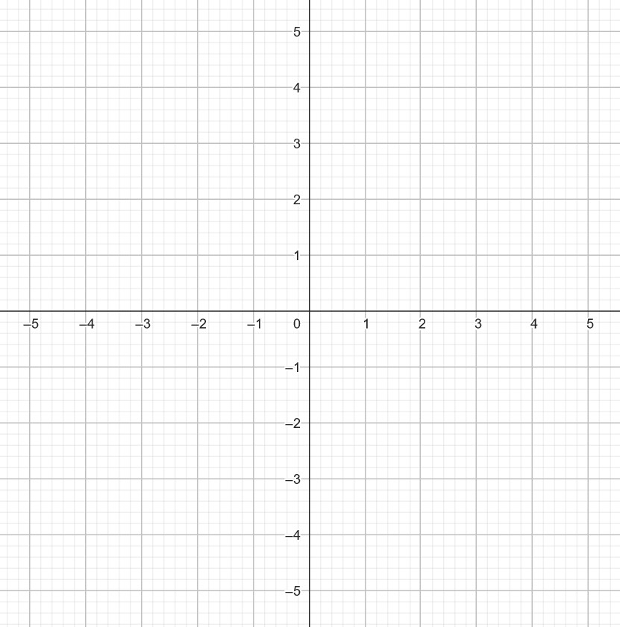
Use the grid to the right to sketch your function (what you see in GeoGebra). Include points that you feel are important,

Q4) Reciprocal functions are bit tougher to deal with. Type “1/x” in your input box and hit enter. Change the sliders, one at a time and describe what each transformation does (remember to see a vertical flip you need to make “a” negative and to see a horizontal flip you need to make “k” negative.)

Describe what Vertical Stretches (a) do to $f\left(x\right)=\frac{1}{x}$

Describe what Horizontal Stretches (k) do to $f\left(x\right)=\frac{1}{x}$

Shifts (“c” and “d”) affect the reciprocal function by

In a blank line of the Input Panel type the equation of the Vertical Asymptote: “x=d”. (Note – here you *do* have to type “x=d” and then hit enter.) Try to make the line dotted. In the next line of the Input Panel (below the line for the vertical asymptote), type the equation of the Horizontal Asymptote. Figure out the correct equation and type it in (and write it here): The Horizontal Asymptote has equation ______________.

What do the shifts do with the asymptotes of the reciprocal function?

Q5) Save your file. Click on the “hamburger menu” (top left) and choose save. Please name your file like this: FirstInitialLastNameTransform. For example, my file would be called “JTempletonTransform”.

Next you need to download your file as a “ggb” file. Under the main menu (hamburger) choose “Download As” and then choose “ggb”. Save the file to your Mac. This is the file you are uploading to be examined by me. Please upload the file to Edsby.

Success Criteria
- I can describe how transformations affect our parent functions.
- I can use GeoGebra to visualize transformations

