

Chapter 4 – Exponential Functions
Additional examples – Doubling and Half-Life

Doubling examples
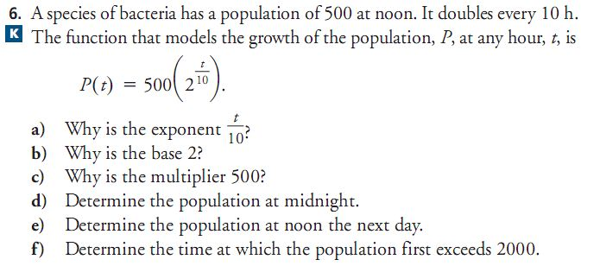
A

B
The bacterium Escherichia coli has a doubling period of 0.32 hours. A culture of E. coli starts with an initial population of 100 bacteria:
a) determine an equation (function model) which describes the population of bacteria.
b) What is the bacteria population after 5 hours?
c) after how many hours will there be one million bacteria?

Half-Life examples
A
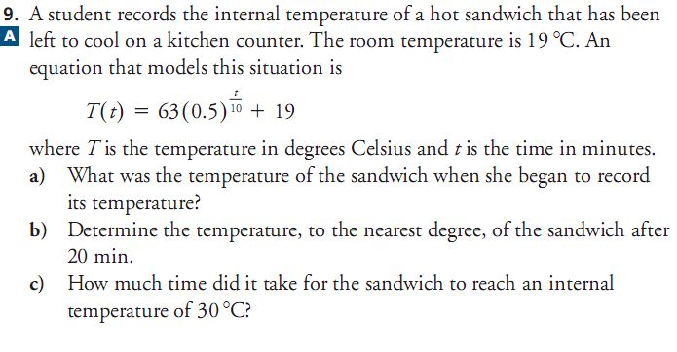

B
Radium has a half life of 1620 years. If a sample of radium begins with 5g of radioactive material, determine:
a) a function which models the decay of the radium’s radioactivity
b) how much od the 5g sample will remain after 150 years
c) How many years will it take to reduce the 5g sample to be reduced to 4g

