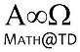
MCR3U

11U5 W24 – Sketching Sinusoidal Functions (practice, but I will be watching you work)

Sketch two cycles of each of the following functions. State: amplitude, period, phase shift and the central axis. Also state the range of each function. You may use whichever technique you like best (“transforming” a table of values or using the “division into quadrants” pattern).

1. Sketch two cycles of $g\left(θ\right)=2cos\left(θ\right)-4$

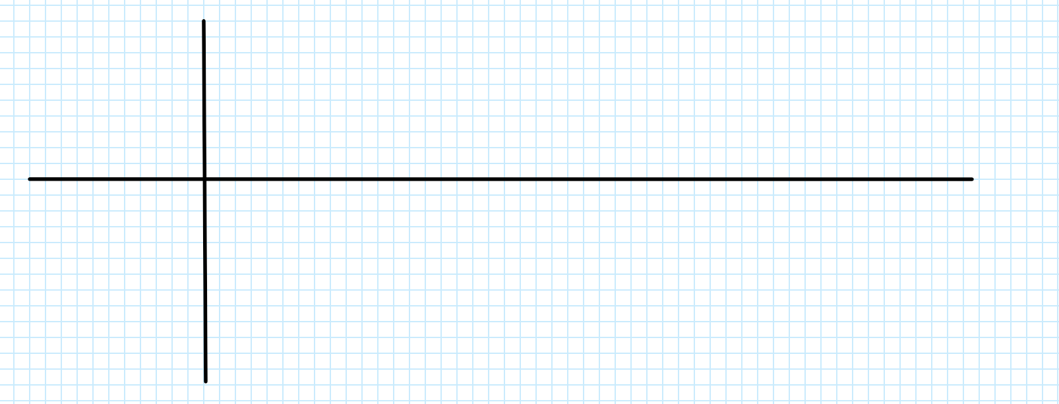

2. Sketch $f\left(x\right)=2\sin\left(x-30°\right)+1$

3. Sketch two cycles of $g\left(θ\right)=3\cos\left(2θ\right)-2$

4. Sketch two cycles of $h\left(x\right)=-2.5\sin\left(3x+180°\right)+3$

