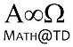
MCR3U

Chapter 1 – Introduction to Functions
1.3 and 1.4 Parent Functions and Domain and Range

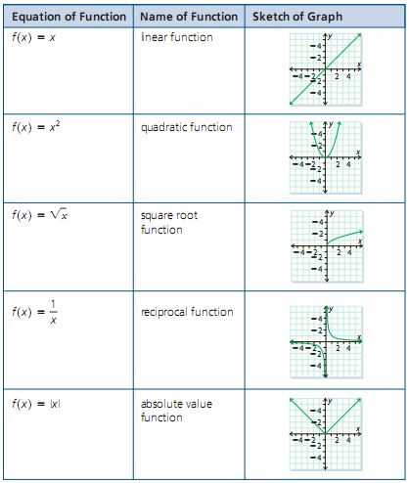
We will be closely studying 5 types of functions (Actually we’ll study more than the following five, but for now….the big five are: )
Domain and Range

Two incredibly important aspects of functions are their

Again, the Domain is

And, the Range is

Example 1.4.1
Given the sketch of the graph of the relation determine: the domain, the range of the relation, and whether the relation is, or is not, a function.
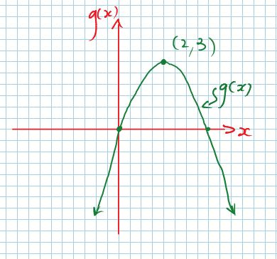
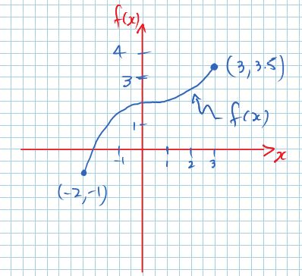
a) b)

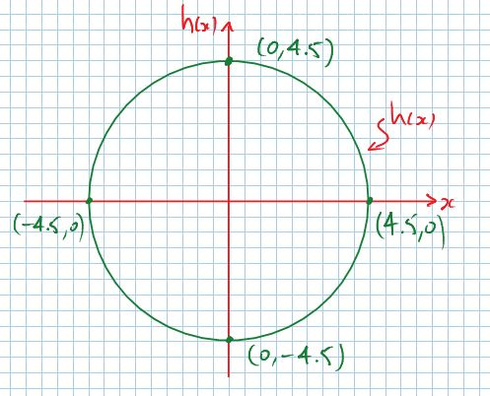
c)

The Parent Functions (for Grade 11)

Together we will explore (graphically) basic properties of the five parent functions:

a) Linear
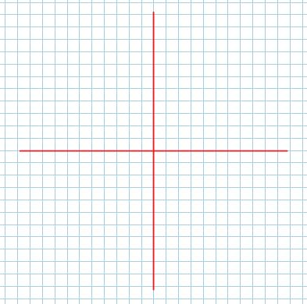

b) Quadratic

c) Square Root

d) Reciprocal e) Absolute Value

Example 1.4.2 (From Pg. 36 in your text)

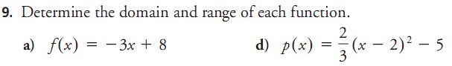
Example 1.4.3 (From Pg. 37 in your text…use Desmos or Wolfram!!)
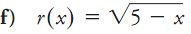

Example 1.4.4
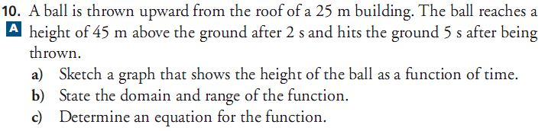

Class/Homework
Read Examples 3 and 4 on pages 32 – 34 in your text
Pg. 35 – 37 #2 (also: which are functions?), 9bce, 11 (use a graphing calculator, or Desmos, or Wolfram|Alpha if you want!), 12, 13, 14 (calculate the functional values for each given domain value)

