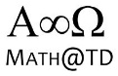

Chapter 4 – Exponential Functions
4.7 – Applications of Exponential Functions

Anything in the real world which grows, or decays can be “modeled” (or in some sense “described”) with words, or pictures or mathematics. Mathematical models are useful for getting solutions to problems, and making predictions.

So far in Mathematics 11U we have studied the basics of functions in general (chapter 1), we’ve done some algebra (chapter 2), and we’ve examined Quadratic functions (chapter 3). Part of our study of Quadratics was learning how to use the vertex of a parabola to answer questions about maxima and minima for some real word problems. For example we saw a question where we tried to maximize revenue for a school store. Quadratic models are very useful for solving max/min problems.

In this lesson we want to work on learning how to solve problems dealing with growth and decay. We have to decide what type of function will best model (or describe) the type of growth/decay seen in the problem (hint: for this lesson we’ll be examining Exponential Growth and Decay, and therefore we expect that exponential functions will be used…shocking, I know)

Q. What is Exponential Growth or Decay?

Consider the following:
A single cell divides into two “daughter” cells. Both daughter cells divide resulting in four cells. Those four cells each divide and we now have a population
of

Describe, using mathematics, how the cell population changes from generation to generation.

Example 4.7.1
Being a financial wizard, you deposit $1 000 into an account which pays 3.5% interest, annually.
- Determine who much money is in your account after t =1,2,3, and 4 years.
- Determine a mathematical model which can describe how the value of the account is changing from year to year.

Definition 4.7.1
A function describing Exponential Growth is of the form:

A function describing Exponential Decay is of the form:

Example 4.7.2
From your text, Pg. 263
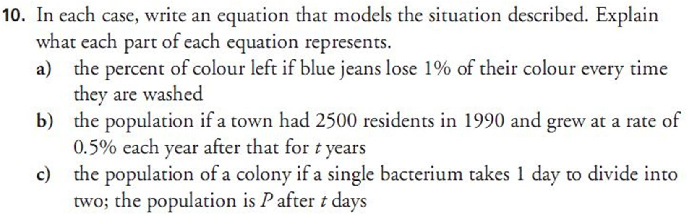

Example 4.7.3
From your text, Pg. 263
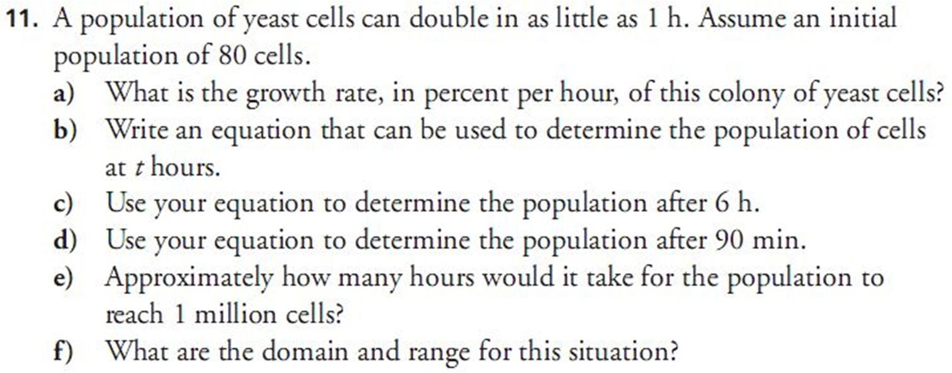

Class/Homework:
READ Example 2 on pages 256 – 257 (which method do you prefer: Guess and Check,
or Graphing Calculator?)
READ Example 4 on pages 259 – 260.
Pg. 261 – 263 #1, 3 – 9, 12 – 16 (you have two days for these problems)

