

Chapter 4 – Exponential Functions
Additional Applications – Doubling and Half-Life

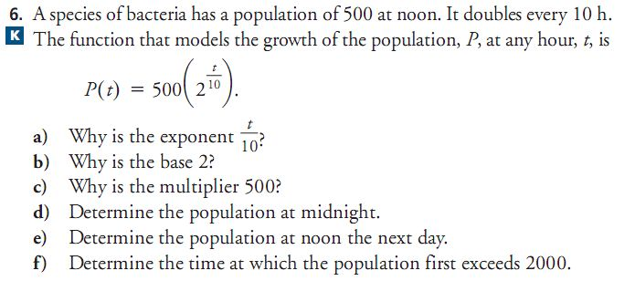
Example (Doubling)

Example (Half-Life)

