

Chapter 6 – Sinusoidal Functions
6.7 – Problem Solving with Sinusoidal Functions

We can use the sinusoidal properties of Period, Central Axis, Amplitude and Phase Shift to describe and solve “real world” problems.

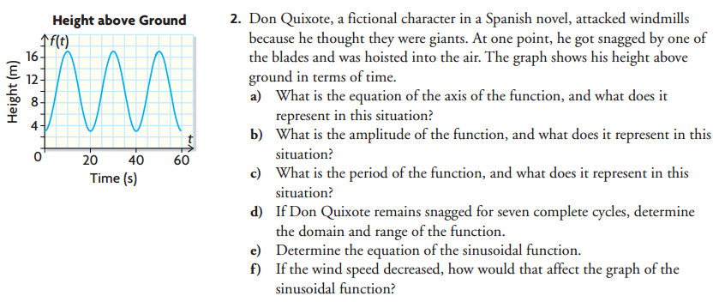
Example 6.7.1 (From the text: Pg. 398 #2)

Class/Homework: Pg 398 – 401 #4 – 6, 8, 10 (a question of beauty)

