
MCR3U – Winter 2013
(Templeton)

Chapter 8 – Financial Mathematics

8.6 – Using the TMV (Time Value of Money) Solver on your Graphing Calculator

Note: You are NOT allowed to be angry with me for showing you this after using formulas!

The TVM Solver can be found under: APPS ->1 ->1

N: This represents the total number of compounding periods (Years*P/Y) in the term of the investment, annuity or loan. This will always be a positive integer.
I%: This represents the nominal rate (the annual interest rate) for an investment, annuity or loan. This will always be a positive integer. Note: We write the percent form here, not the fraction or decimal form of a percent.
PV: This represents the present value of an investment, loan or annuity. This number can be positive or negative. If the number is positive, then it indicated money we collected as in a loan. If the number is negative, then it represents money we paid out, as in an investment or loan where we are the lender.
PMT: This represents the regular payment made to build an annuity or pay off a loan. The value will always be negative in these situations. If we have a 'payout' annuity, then the value will be positive. In either case, the value represents the payment per compounding period. PMT can be positive if you are constantly taking an equal sum of money out of an investment.
FV: This represents the future value of an investment, annuity or loan after N compounding periods have passed. This value will be positive or negative depending on the signs of PV and PMT.
P/Y: This value represents the number of payments per year for annuities and loans. This must be a positive integer.
C/Y: This represents the number of compounding periods per year. This must be a positive integer.
Note: If PMT = 0, then set P/Y = C/Y (in fact it is usual for P/Y to equal C/Y).

Remember: Money going away is negative, while money coming in is positive.

PMT: END BEGIN. This field allows one to set the TVM Solver for 'ordinary' annuities, (END), or annuities 'due' (BEGIN).
General rule: Select END in the last line of the entries unless the problem states otherwise (beginning of the month).

To Solve a problem, enter in the information that you are given, go to the line you that you want to calculate and press ALPHA -> ENTER

Example 8.6.1
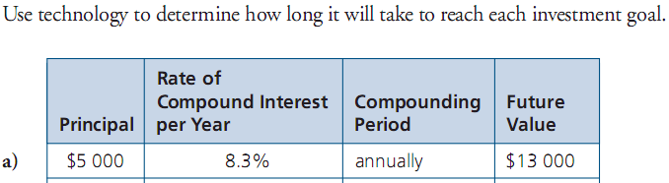
From your text: Pg. 530 #1a

Example 8.6.2
From your text: Pg. 530 #2c
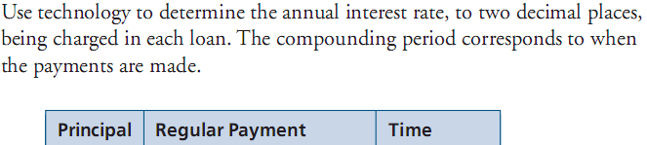

Example 8.6.3
From your text: Pg. 531 #6
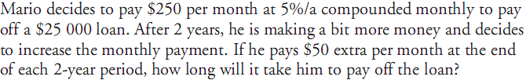

Class/Homework: Pg. 530 – 531 #1cd, 2ad, 3, 4, 7, 8

