**Section 1.1: Page 13 Name: __________________**

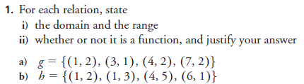

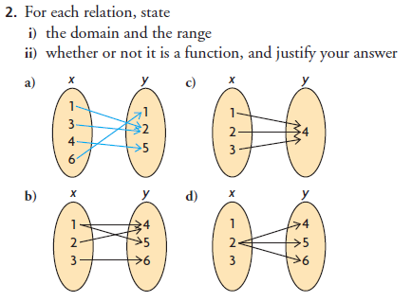

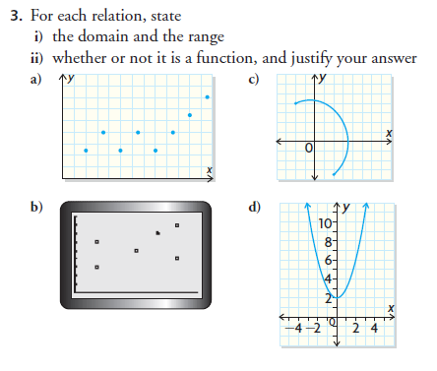

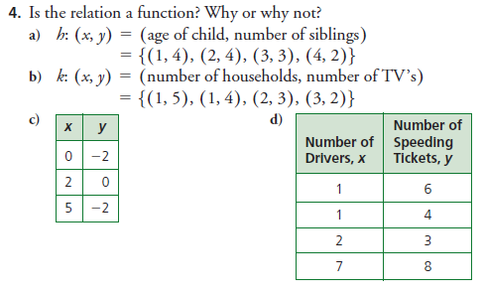

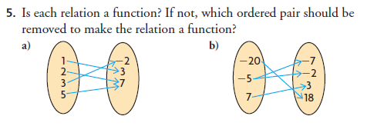

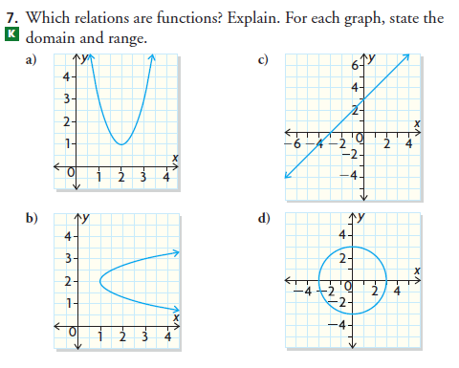

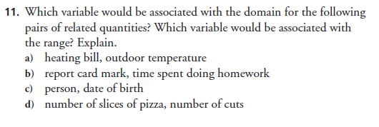

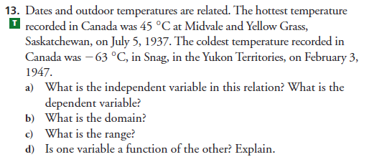

**Section 1.3: Page 33**



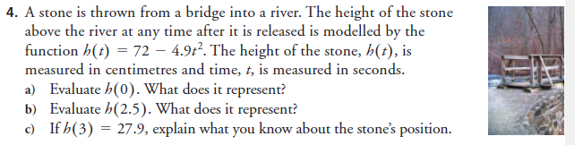

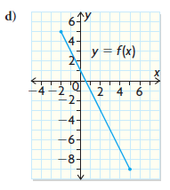

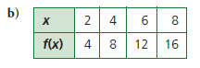



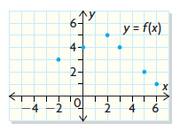



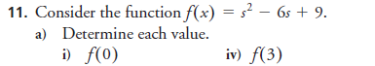





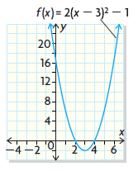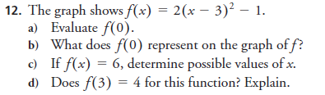

**Section 1.6: Page 56**

1. State the transformations for the following functions.





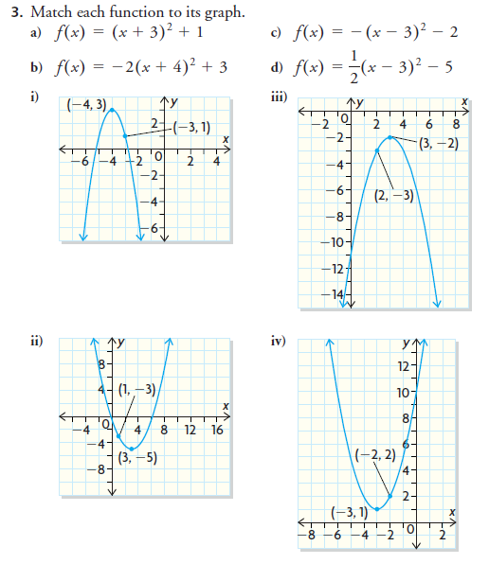







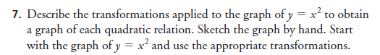

|  |  |
| --- | --- |
|  |  |
|  |  |
|  |  |

So far in the unit, what are the most confident with?

So far in the unit, what are your greatest struggles? What is your plan to strengthen your skills in this area?

**Section 1.7: Page 64**





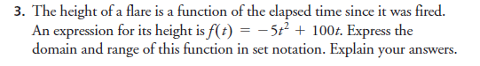

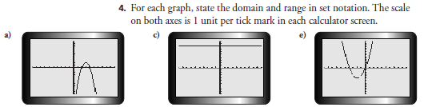

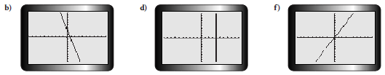

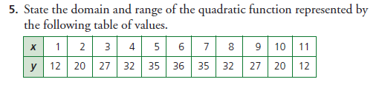

6. Use graphing software, like Desmos, to graph each function. Sketch the graph below. Then, state its domain and range.



