**Chapter 7 Homework: Exponential Functions**

*Contents with suggested problems from the Nelson Textbook. You are welcome to ask for help, from myself or your peers, with any of the following problems. They will be handed in on the day of the Unit Test as a homework check. Alternatively, you may be handing your homework in more regularly for me to correct.*

Section 7.2 – Page 399

#1-9, 11, 17 (do only some of each. Two-Three is a good number)

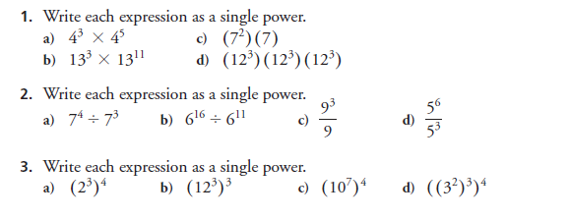

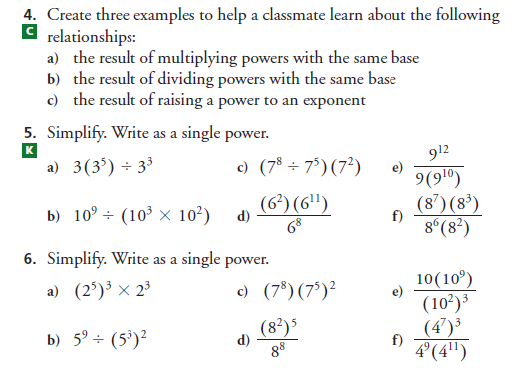

An Important Note:

**Simplify** means “write as a single exponent, using the exponent laws”

**Evaluate** means to give me the actual number you get

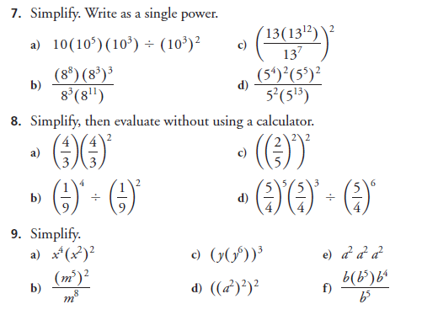

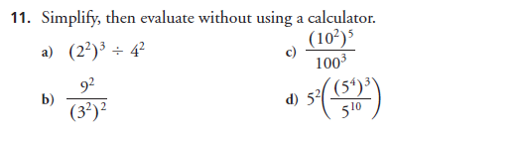

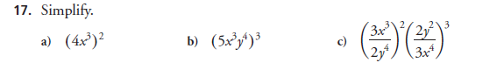

Section 7.3 – Page 407

#1-9, 11 (do only some of each)

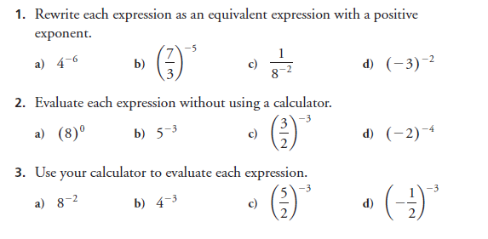

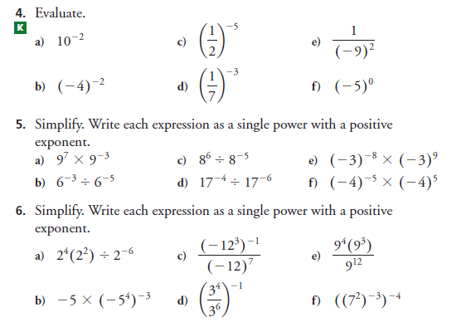

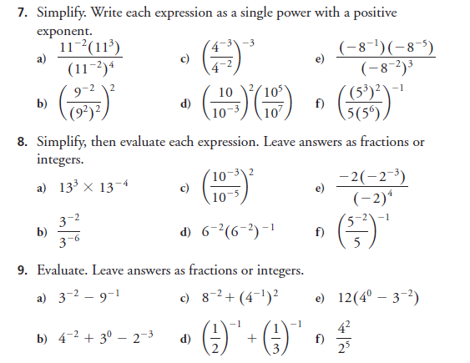

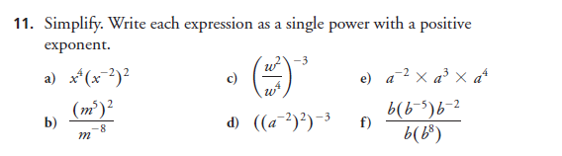

Section 7.4 – Page 415

#1-3, 6, 7, 9, 10 (do only some of each)

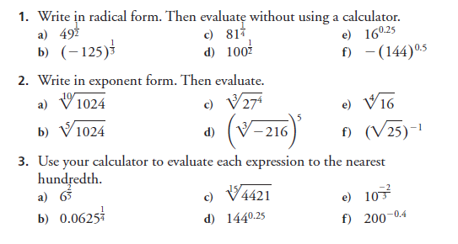

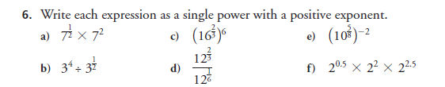

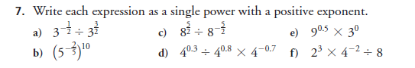

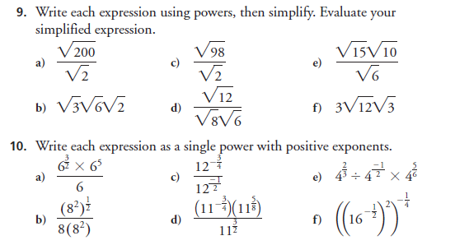

Section 7.6 – Page 429

#1-11 (14 and 15 are interesting too)

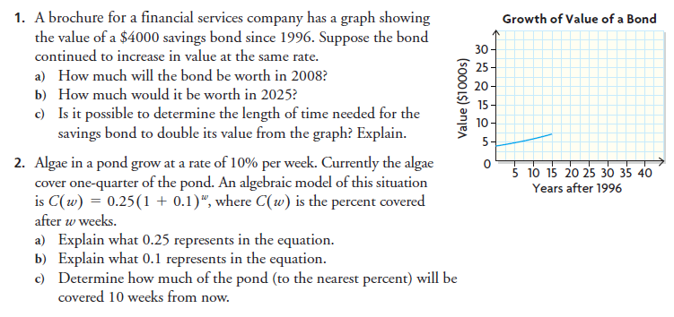

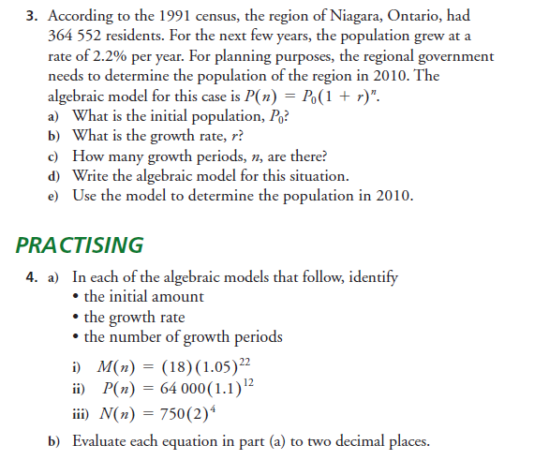

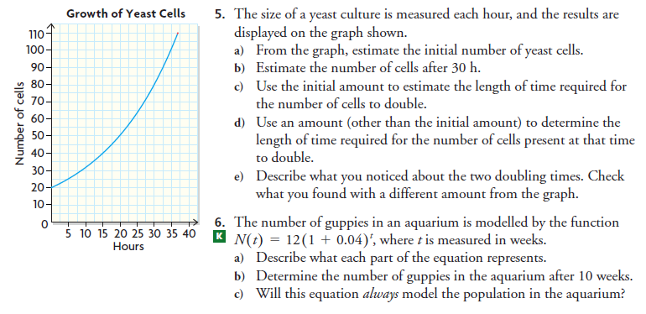

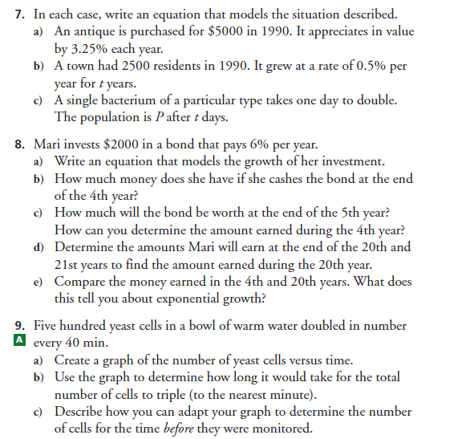

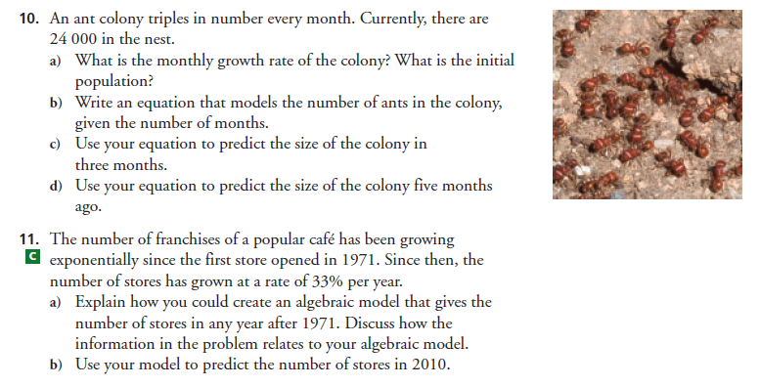

Section 7.7 – Page 437

#1, 3, 4, 7-10, 12, 14

