**Math 9 – Unit 5: Measurement**  Name: ____________________

**Lesson #1: Perimeter and Area of 2D Figures**  Date: _____________________

**Learning Goal:** We are learning to calculate the perimeter, circumference, and area for common 2D simple and compound shapes.

Welcome back to Mathematics! We will kick off our second half with a unit which you should be familiar with. There will be some new ideas, but overall, this is always a great unit to get back into Math. Let’s dive in.

**Important Formulas**

Perimeter – simply add up all the outside edges, regardless of the shape (not circles!)

Area of a square/rectangle: *A = lw* Area of a triangle: $A=\frac{1}{2}bh$ or $A=\frac{bh}{2}$

Area of a trapezoid: $A=\frac{\left(a+b\right)h}{2}$

Area of a circle: $A={πr}^{2}$ (pi = 3.14) Circumference of a circle: $C=2πr$

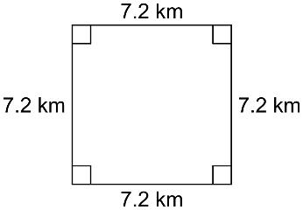**Find the perimeter (if possible) and area of each shape.**

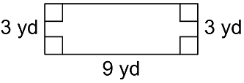1. 2.

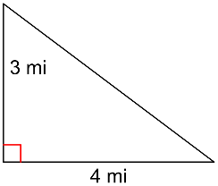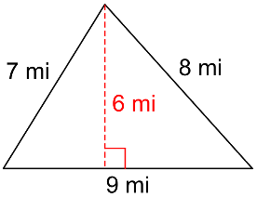3. 4.

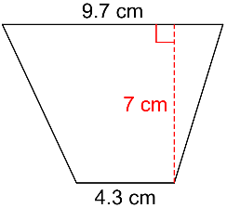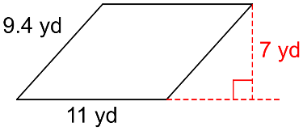

5. 6.

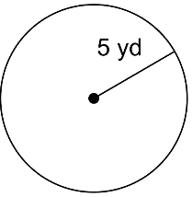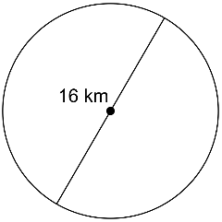**Find the circumference and the area of each circle.**7. 8.

**Use the appropriate formula to find the missing piece.**

|  |  |
| --- | --- |
| 9. A triangle has a height of 22*cm* and an area of 143*cm2*. What is the length of the base? | 10. A large pizza has an area of 201*in2*. What is the diameter, in inches, of the pizza. |

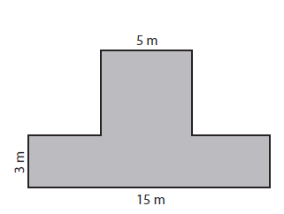**Find the area of the compound figures.**11.

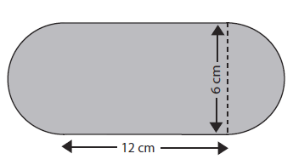12.

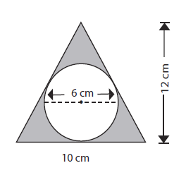13.

**Success Criteria:**

* I can find the perimeter and area of a square, rectangle, triangle, parallelogram, or trapezoid
* I can find the circumference and area of a circle
* I can find the area of compound shapes by breaking them down into simpler shapes
* I can, if given the area, find another missing dimension