**Math 9 – Unit 5: Measurement**  Name: ____________________

**Lesson #2: Rectangular and Triangular Prisms**  Date: _____________________

**Learning Goal:** We are learning to calculate the surface area and volume for common 3D shapes and composite figures.

**Some Strategies**

* When looking at surface area
  + Draw the net or label each side of the shape with letters (so you don’t forget any!)
  + Find the area of each 2D shape by itself, using yesterday’s formulas, then add all of them together
* When looking at volume
  + Be careful what you pick as the base
  + Divide composite objects into smaller simple 3D shapes and find the volume of each, then add all of them together.

**Important Formulas**

Volume is always the “area of the base” × “the height”

Volume of a rectangular prism: $V=lwh$ Volume of a triangular prism: $A=\frac{1}{2}bhl$ OR $A=\frac{bhl}{2}$

**For each figure, draw the net, then calculate the surface area and the volume.**

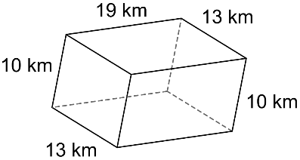1.

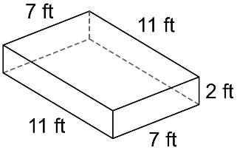 2.

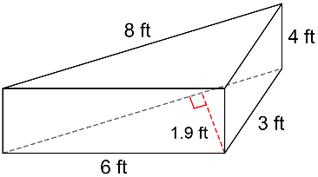3.

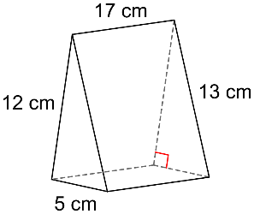 4.

**Use the appropriate formula to solve for the missing measurement.**5. A rectangular prism has a volume of 5940*cm2* with a height of 15*cm* and a length of 33*cm*. What is the width of the box?

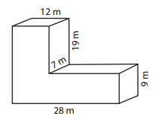6. Calculate the surface area and the volume of the composite figure.

**Success Criteria:**

* I can find the surface area of prisms by adding up the areas of each side
* I can find the volume of prisms by using the appropriate formula (area of the base × height)
* I can find the surface area of composite figures by breaking it down into smaller parts and finding the surface area of each part
* I can find the volume of composite figures by breaking it down into smaller parts and finding the volume of each part