**Math 9 – Unit 5: Measurement**  Name: ____________________

**Lesson #3: Cones and Cylinders**  Date: _____________________

**Learning Goal:** We are learning to calculate the surface area and volume of cylinders and cones.

**Important Formulas**

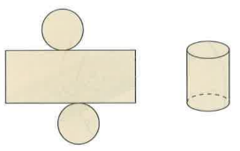Surface area of a cylinder = area of the rectangle + 2x area of circular base

$$SA=\left(2πrh\right)+2(πr^{2})$$

Volume of a cylinder = area of the base × height

$V=πr^{2}h$

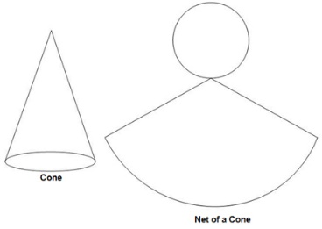Surface area of a cone = lateral area + area of the circular base

$$SA=πrs+πr^{2}$$

Cones are tricky because you need to know the slant height. Which means, we will need the Pythagorean theorem!!!

$$s^{2}=r^{2}+h^{2}$$

Volume of a cylinder = $\frac{1}{3}$ the volume of a cylinder with the same base!

$V=\frac{1}{3} πr^{2}h$ OR $V=\frac{πr^{2}h}{3}$

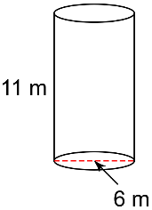**For each figure, draw the net, then calculate the surface area and the volume.**

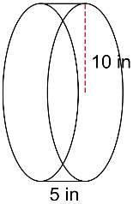1. 2.

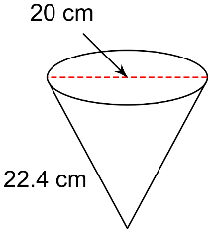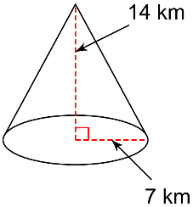3. 4.

**Use the appropriate formula to solve for the missing measurement.**5. A Cylinder has a volume of 2769.48*cm3* with a height of 18*cm*. What is the length of the radius?

**Success Criteria**

* I can draw the net of a cylinder or cone
* I can use the appropriate formula to find the surface area or volume of a cone or cylinder
* If given the volume of a cone or cylinder, I can rearrange the equation to find the radius or height.