**Math 9 – Unit 5: Measurement**  Name: ____________________

**Lesson #3: Pyramids and Spheres**  Date: _____________________

**Learning Goal:** We are learning to calculate the surface area and volume of square pyramids and spheres.

Like our earlier shapes, we can figure out formulas for surface area and volume by looking at the nets of some of these shapes. Not as helpful with spheres though…

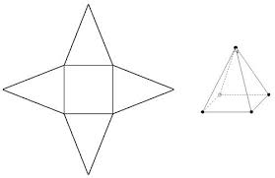**Important Formulas**

Surface area of a pyramid = area of square base + 4 identical triangles

$$SA=lw+4\left(\frac{1}{2}ls\right)$$

$$SA=b^{2}+2bs$$

Volume of a square pyramid = $\frac{1}{3}$ volume of a rectangular prism with the same base!

$V=\frac{1}{3}lwh$ OR $V=\frac{lwh}{3}$

Surface area of a sphere: $SA=4πr^{2}$

Volume of a sphere: $V=\frac{4}{3}πr^{3}$ OR $V=\frac{4πr^{3}}{3}$

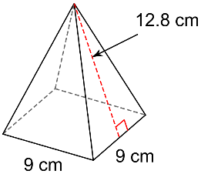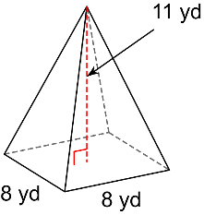**For each figure, draw the net, then calculate the surface area and the volume.**

1. 2.

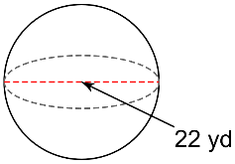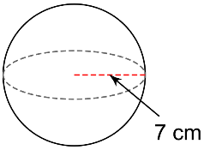3. 4.

**Success Criteria:**

* I can draw the net of a square pyramid
* I can use the appropriate formula to find the surface area or volume of a square pyramid or sphere