**Math 9 – Unit 6: Coordinate Geometry** Name: ____________________

**Lesson #1: The Coordinate Plane**  Date: ______________

**Learning Goal:** We are learning how to use the coordinate grid system.

In this chapter and the next, we will learn a lot of new vocabulary. You need to become intimate with these words, so let’s first define them, then draw/label them!

**Coordinate Plane**

**Quadrants**

**x-axis**

**y-axis**

**x-coordinate**

**y-coordinate**

**Ordered Pair**

**Origin**

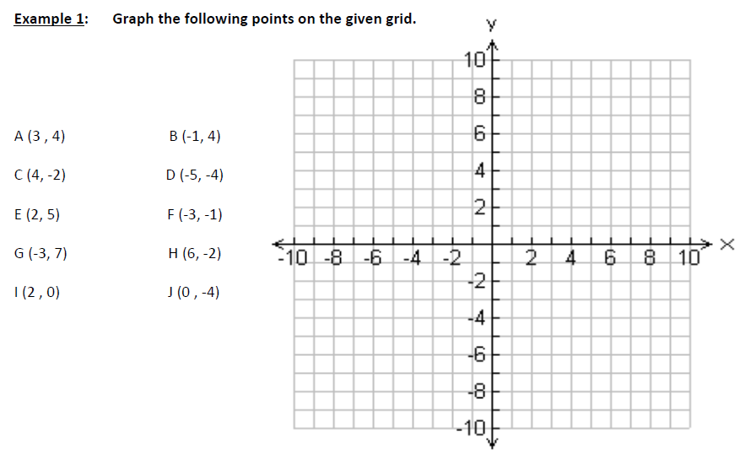

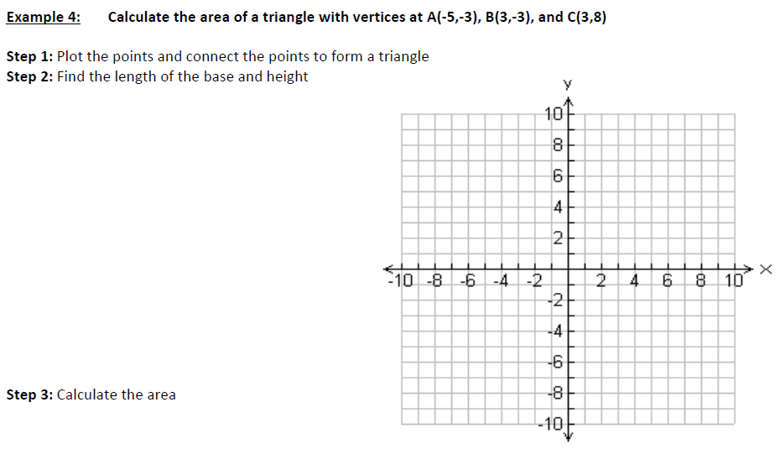

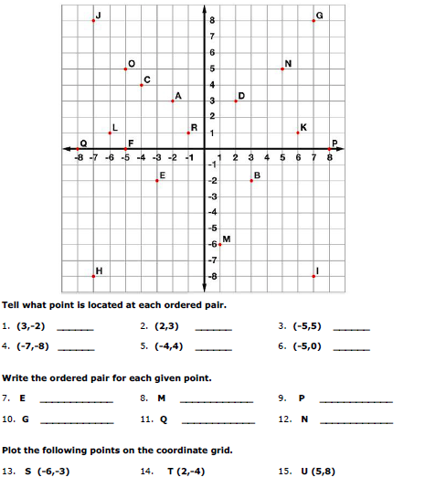

**Success Criteria:**

* I can define the important key terms that are used in the coordinate grid system
* I can tell the difference between the “x” and “y” coordinates in an ordered pair
* I can find an ordered pair on a coordinate grid