**Math 9 – Unit 6: Coordinate Geometry** Name: ____________________

**Lesson #2: Graphing Linear Relationships** Date: ______________

**Learning Goal:** We are learning to create a table of values from a linear equation and use that table to create a list of ordered pairs that can be plotted on a coordinate grid.

Once again, we will begin with some new vocabulary:

**Independent Variable**

**Dependent Variable**

**Linear Relationship**

**Table of Values**

The goal for today’s lesson is to graph a linear relationship using this algorithm:

**1. Rearrange the equation so it is dependent variable = everything else (or y=_____)  
2. Create a Table of Values and choose an appropriate set of x-coordinates.  
3. Use that set and calculate the corresponding y-coordinates.  
4. Create the point (x,y).  
5. Plot the points.  
6. Draw a line through the points (do not just connect them).**

Your table of values should look like this:

|  |  |  |
| --- | --- | --- |
| x | y | (x,y) |
| Set of x-coordinates | Corresponding y-coordinates | Set of points to plot |

Examples:

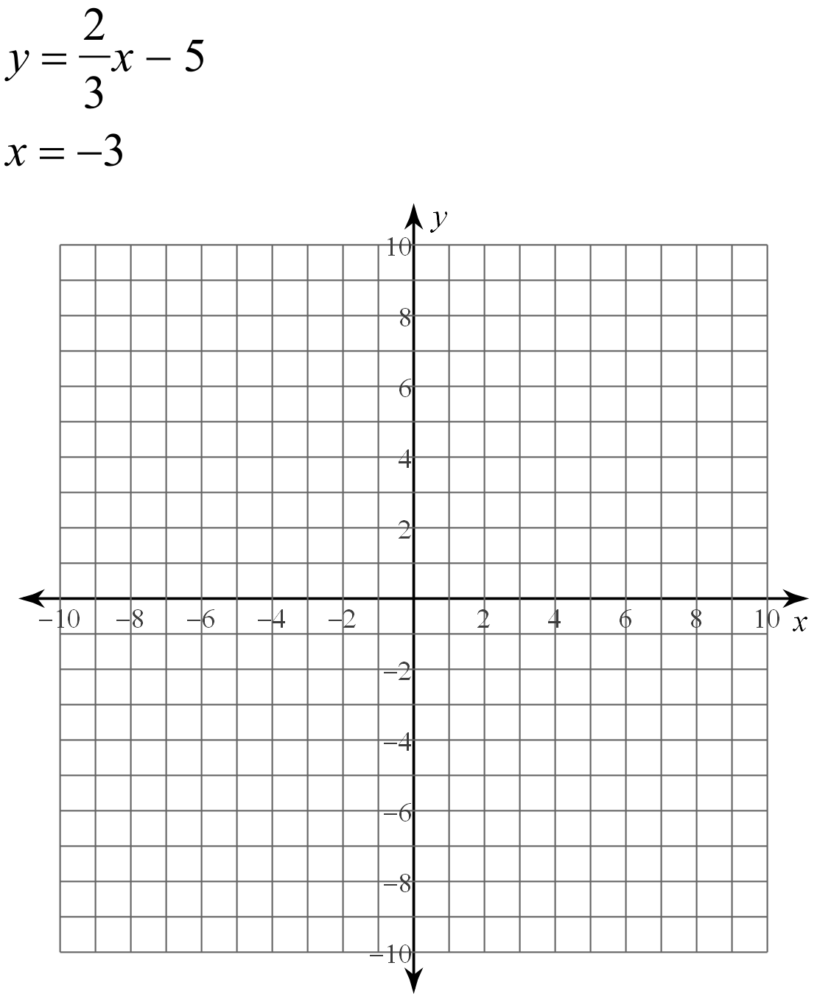1. 

2. 

3. 

4. 

5. 

6. 

**Success Criteria:**

* I can rearrange a linear equation so that the “dependent variable = everything else”
* I can create a table of values and choose an appropriate set of x coordinates.
* I can use those x-coordinates to generate a set of y-coordinates
* I can create ordered pairs from the sets of x and y coordinates and graph my ordered pairs on a coordinate grid