**Math 9 – Unit 7: Coordinate Geometry** Name: ____________________

**Lesson #3: Slope of a Line**  Date: ______________

**Learning Goal:** We are learning how slope impacts a linear equation. It’s all downhill from here!

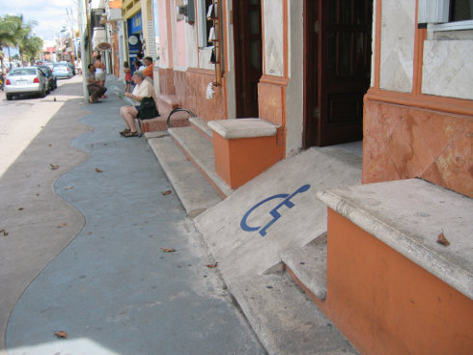In this lesson, we will explore the most significant property of a linear relationship: the slope! The slope of a line tells us how the relationship is changing and can be thought of as how slanted/steep the line is. It has many important applications such as engineering the initial climb of a roller coaster to making safe ramps, but today we will focus on the algebra and understanding how to calculate the slope of a line.

First, let’s look at the slope from a geometric perspective. The slope, defined by the letter *m* for no apparent reason, is: 

**Example 1: Given the line with two points, calculate the slope.**

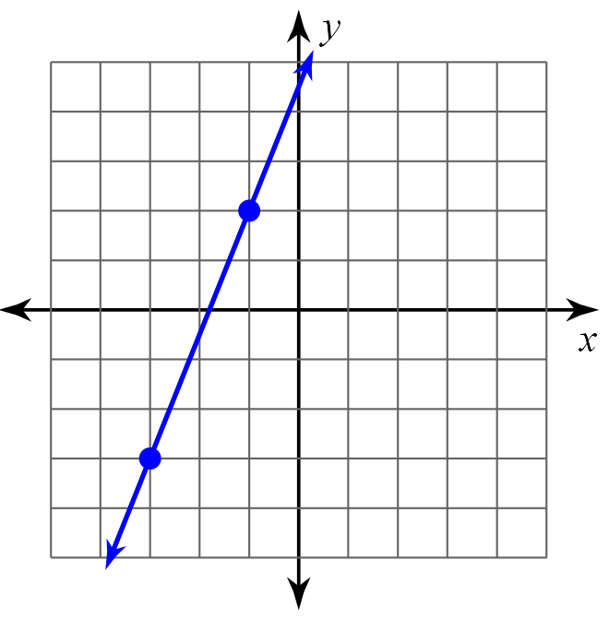

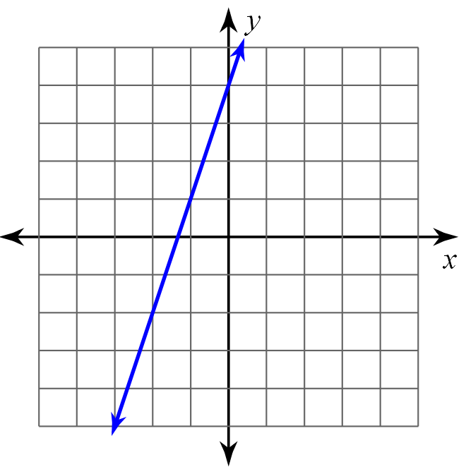**Example 2: Given the line, locate two points, then calculate the slope.**

Are slopes always positive? There are 4 possible slopes:

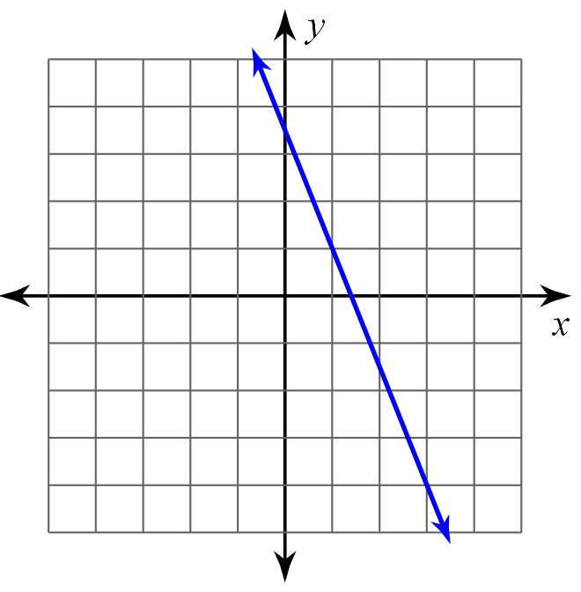**Example 3 and 4: Calculate the slopes of each line.**

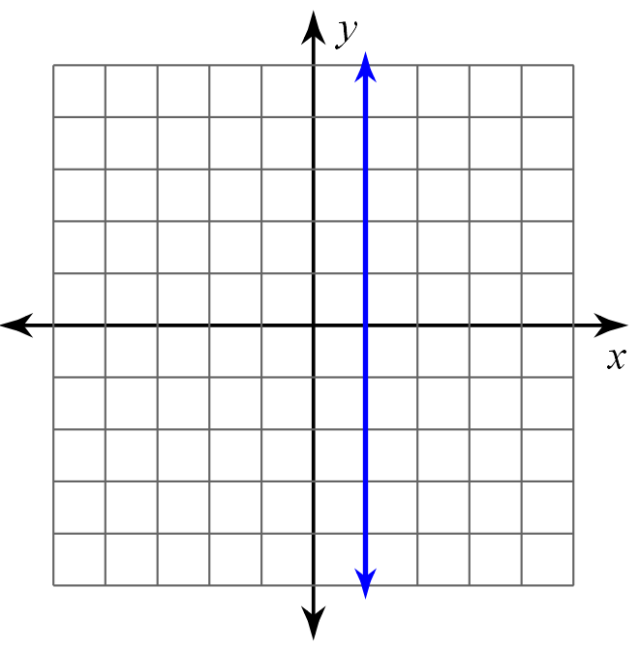

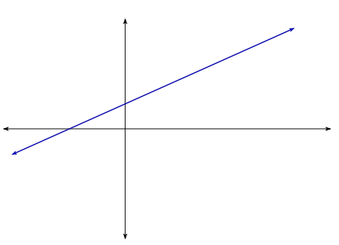**Now that we know about slope, we can derive a formula so that we do not need a graph.**

**Examples 5-8: Given the points, calculate the slope.**

5.  6. 

7.  8. 

**Example 9:** A ramp needs to be constructed to go from the ground to a doorway. The doorway is 90 cm from the ground and the ramp needs a slope of $\frac{2}{9}$.

a) Calculate how far the ramp will start from the edge of the house.

b) Calculate the length of the ramp.

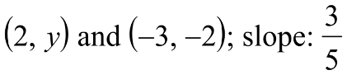**Example 10 and 11: Calculate the missing coordinate.**

**10.**

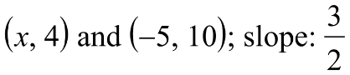

**11.**

**Success Criteria**

* I can identify the four types of slope: positive, negative, zero, undefined
* I can find the slope of a line graphically by studying its $\frac{rise}{run}$
* I can calculate the slope of a line algebraically by using the formula $m=\frac{y_{2}-y_{1}}{x_{2}-x_{1}}$
* I can find a missing coordinate, if given the slope