**Math 9 – Unit 7: Coordinate Geometry** Name: ____________________

**Lesson #4: Slope as a Rate of Change Part 1**  Date: ______________

**Learning Goal:** We are learning to connect rate of change to the slope of a line.

To explore what “rate of change” is, we first need to refamiliarize ourselves with “rate”. A **rate** is a comparison of two quantities expressed as different units:

Examples:

A line on a graph is always changing (unless it is flat or ). Rate of change, then, is the rate at which a line on a graph is changing. Thankfully, we know how to calculate this change by calculating the slope! Thus,

Rate of change = slope =  = $\frac{y_{2}-y_{1}}{x_{2}-x_{1}}$ = Rate of change

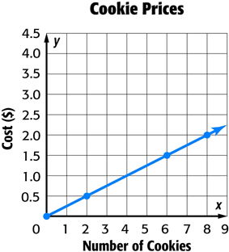**Example 1:** Given the graph to the right:

**a)** Calculate the rate of change. Include the units (always include units).

**b)** What does the rate of change represent?

**c)** How much would 7 cookies cost? If I spent one dollar, how many cookies would I get?

**d)** The information for question c) was in the graph. The rate of change allows us to go beyond the graph. How much would 20 cookies cost?

**Example 2:** Timmy drives a cab. He charges $5 for every trip plus $1.50 for every kilometer driven.

**a)** Create a table to represent 0 to 10 kilometers, then graph the table. Label the axes and give the graph a title.

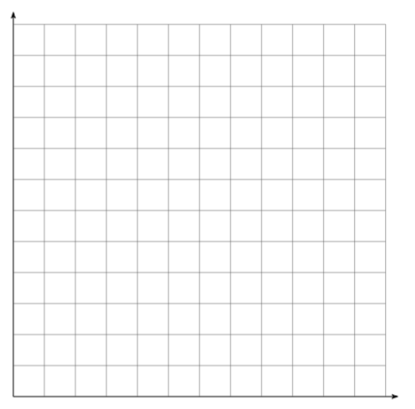

|  |  |
| --- | --- |
| Distance (km) | Cost ($) |
| 0 | 5 |

**b)** What is the rate of change, and what does it represent?

**c)** What is the cost of a 7.5km cab ride with Timmy?

**Success Criteria**

* I can recognize that slope and rate of change are the same thing
* I can find rate of change on a graph, by finding its slope
* I can find the rate of change in a table of values, by finding the common difference