**Math 9 – Unit 7: Coordinate Geometry** Name: ____________________

**Lesson #5: Slope as a Rate of Change Part 2**  Date: ______________

**Learning Goal:** We are learning to use “Average Rate of Change” when slopes change and to calculate rate of change from the equation of a line.

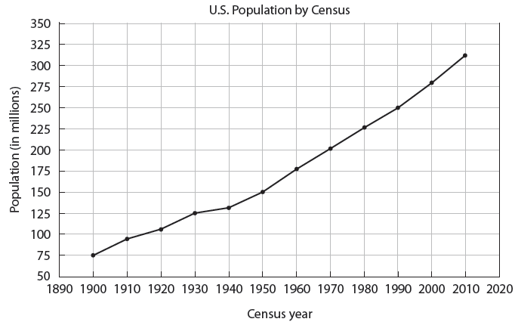In our last lesson, we learned that the Rate of Change is just the slope of a line. However, what if we don’t have one straight line? Look at the following graph:

**What is the rate of change from 1900 to 2000?**

**What is the rate of change from 2000 to 2010?**

**Which decade has the slowest population growth?**

As you can see, the rate of change is not the same throughout the 110 years. When we calculate the rate of change in this situation (over the entire 110 years), we call it the **Average Rate of Change.**

**Rate of Change Without a Graph**

Having a graph is great as it allows us to visualize the information and actually see the steepness (or its flatness, yes, that’s a word). However, we do not always have a graph:

**Example 1**: A climber is on a hike. After 2 hours, he is at an altitude of 400 feet. After 6 hours, he is at an altitude of 700 feet. What is the average rate of change?

**Wait—**why are we asking for the average rate of change?

Since rate of change = slope, the rate of change is also . If we could create two points, we could then calculate the slope/RoC!

**Solve Example 1:**

**Example 2:** A scuba diver is 30 feet below the surface of the water 10 seconds after he entered the water and 100 feet below the surface after 40 seconds. What is the scuba diver’s rate of change?

**Example 3:** A rocket is 1 mile above the earth in 30 seconds and 5 miles above the earth in 2.5 minutes. What is the rocket’s rate of change in miles per second? What about miles per minute?

**Example 4:** A plane left Chicago at 8:00 A.M. At 1: P.M., the plane landed in Los Angeles, which is 1500 miles away. What was the average speed of the plane for the trip?

**Example 5:** Susan is paid a base salary plus commission for selling kitchen appliances. One week, her sales totalled $3800, and she earned $594. In a busier week, her sales totalled $5750, and she earned $652.50.

a) What is commission? Give examples.

b) Given as a percentage, what rate of commission is Susan paid?

c) What is Susan’s weekly base salary?

d) How much would Susan earn in a week if her sales totalled $4325?

**Success Criteria**

* I can identify the rate of change for only a small section of a graph
* I can create two ordered pairs from a given scenario or equation and find the average rate of change between them
* I can use the slope formula to calculate average rate of change