**Math 9 – Coordinate Geometry**  Name: _____________________

**Lesson #1: The Coordinate Plane Homework** Due Date: ______________ 5A ____

**Question 1: Plot the points on the provided coordinate plane**

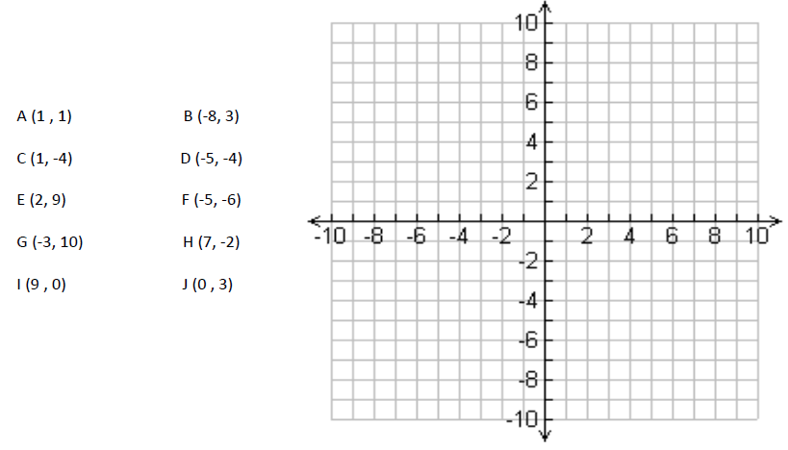

**Question 2: Plot and join the set of points in order. Join the last point to the first point to create a closed figure. Identify the figure then calculate its area in square units.**

