**Math 9 – Coordinate Geometry**  Name: ____________________

**Lesson #5: Slope as a Rate of Change Part 2 - Homework** Due Date: ________________ 5K____

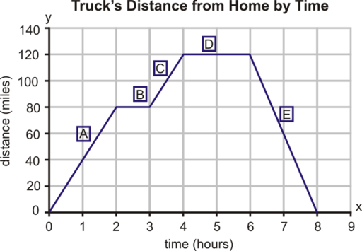1. Given the graph to the right:

a) Calculate the rate of change for each section.

b) What does the rate of change represent?

c) What happened during the 2-3 hour and 4-6 hour intervals?

d) Calculate the average rate of change from 0 to 8 hours. Why does this not make sense?

2. In 1992, the price of an annual membership at Mr. Jensen’s health club was $225. In 2002, the price of the same membership was $319.50. Find the rate of change in the price of the annual membership between 1992 and 2002.

3. After 30 baseball games, Josh Donaldson had 25 hits. If after 100 games he had 80 hits, what is his average hits per baseball game.

4. Last Saturday Steve and Kelly went hiking in the mountains. When they started back at 2:00 P.M., their elevation was 3,560 feet above sea level. At 6:00 P.M., their elevation was 2,390 feet. Find the average rate of change of their elevation between 2:00 P.M. and 6:00 P.M.

5. in 1971, there were 323,000 university students in Canada. In 1997, there were 544,000 students enrolled in a Canadian university.

a) Find the average rate of change, to the nearest hundred students per year.

b) Look up how many students are currently (within the past 5 years) enrolled in Canadian universities. Fill in the blank:   
There are ________________________ students in the year ______.  
Now calculate the average rate of change from 1997 to the year above.

c) Is the rate of change in b) bigger than the rate of change in part a)? Why do you think that is?

6. Because light travels much faster than sound, you see lightning before you hear a thunderclap. If a storm is 960m from you, the time interval between the flash and the thunderclap is 2.8 seconds. If a storm is 1680m from you, the time interval is 4.9 seconds.  
a) Determine the rate of change, to the nearest metre per second.

b) Describe this rate of change in words.

c) If the time interval is 3.7 seconds, determine your distance from the storm.

d) If you are 2500 metres from the storm, what is the time interval?

7. This unit is now done. What part are you most worried about for the test? (Plotting points, graphing lines, slope, rate of change). How can I help you be successful on the test?