**Math 9 – Analytic Geometry**  Name: ____________________

**Lesson #1: Slope Intercept Form (part 1)** Date: ______________

**Learning Goal**: We are learning to identify properties of liens by using the slope-intercept form of a line.

Now that we have looked at the fundamentals of Coordinate Geometry (plotting points, graphing lines and calculating slope), we are now going turn our focus to analyzing lines, dissecting information, and making decisions on how to create equations. All the skills that you learned in Coordinate Geometry are essential to this unit.

In Analytic Geometry, we will learn about:  
 - two forms/equations to represent a line (and how to graph, create and use them)  
 - a third equation which will help us derive the first two  
 - x and y intercepts  
 - intersecting lines  
 - parallel and perpendicular slopes/lines

Today, we will learn about the all-powerful **Slope Intercept Form**, also known as the equation .

Let’s break down the equation.





**Example One – State the slope and y-intercept**

a)  b) 

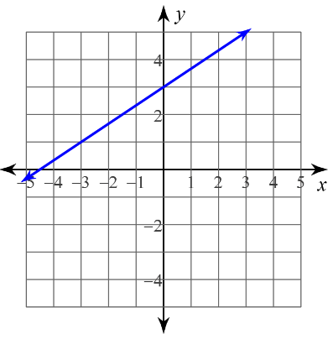

c)

*Whoah!* Wait a minute. In c), we looked at the graph and determined the slope and the y-intercept. Since the equation of a line is *y = mx + b* with *m = slope* and *b = y-int*, what would the equation of line to c) be?

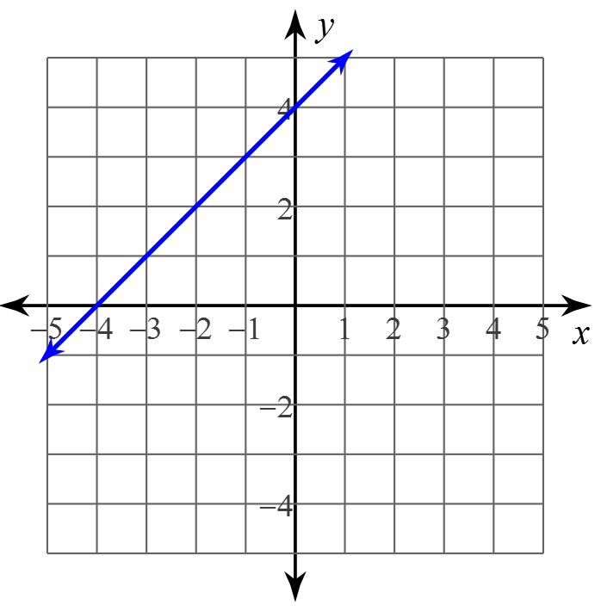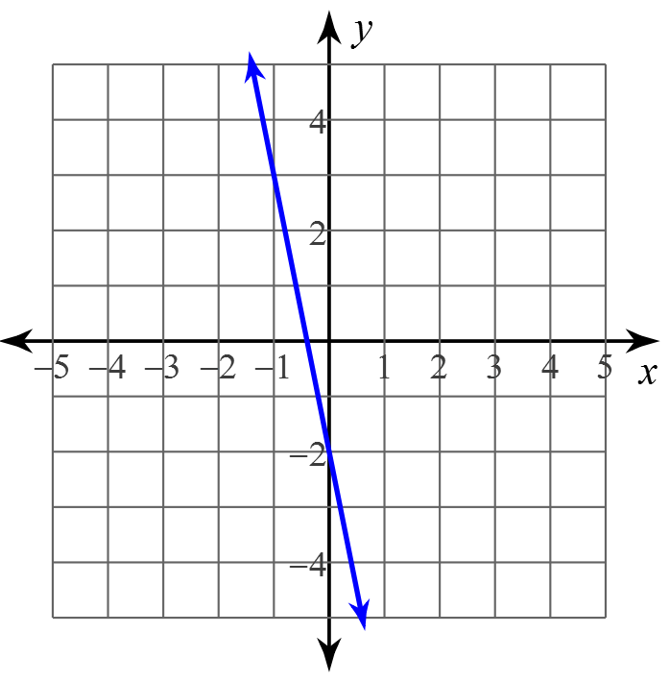**Example Two: Determine the equation of line.**

**Graphing Lines:** The power of  comes with graphing. No longer do we have to make a table of values, instead we will use the properties of the equation. What makes this process amazingly exciting is that it is super duper fast.

Step 1: Turn into  if it is not already.  
Step 2: Plot the y-intercept  
Step 3: From the y-intercept, use your slope (rise over run) to find the next point. (repeat if needed)  
Step 4: Draw the line.

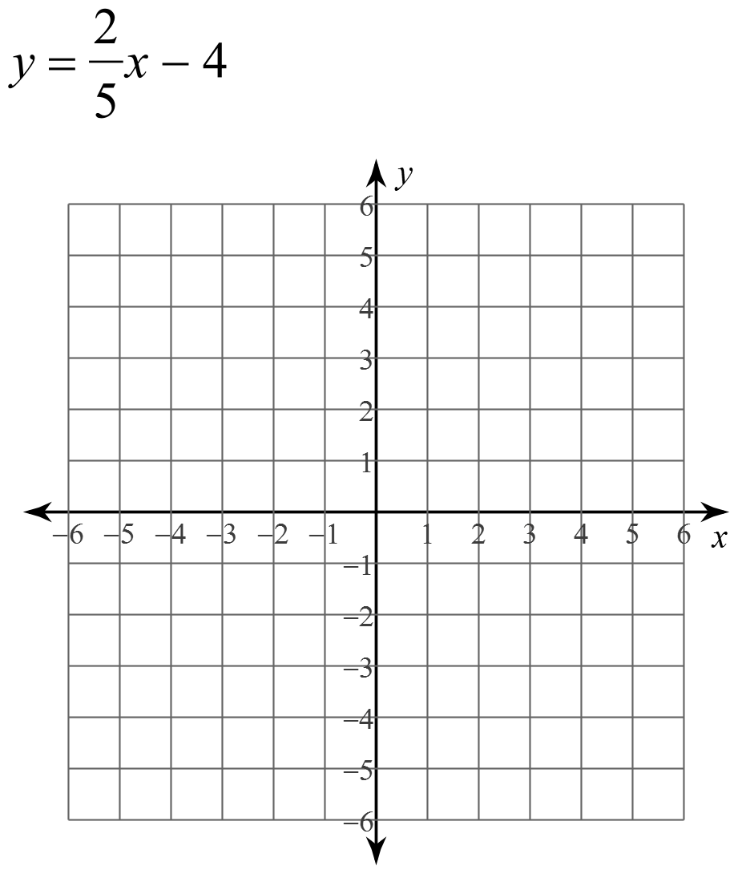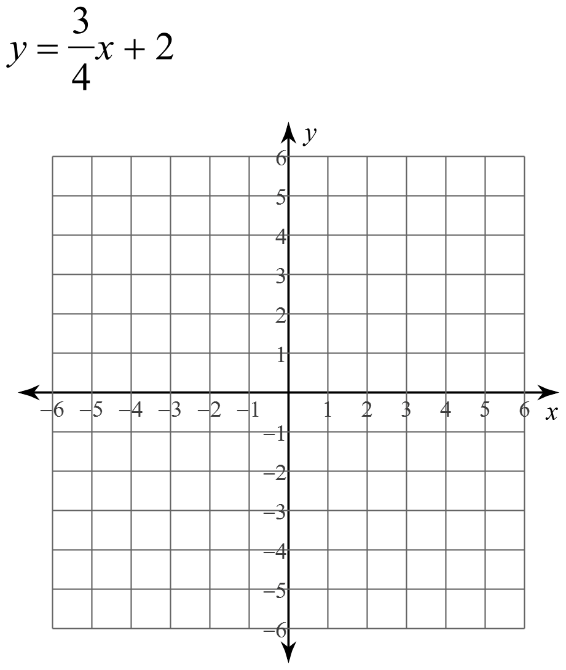

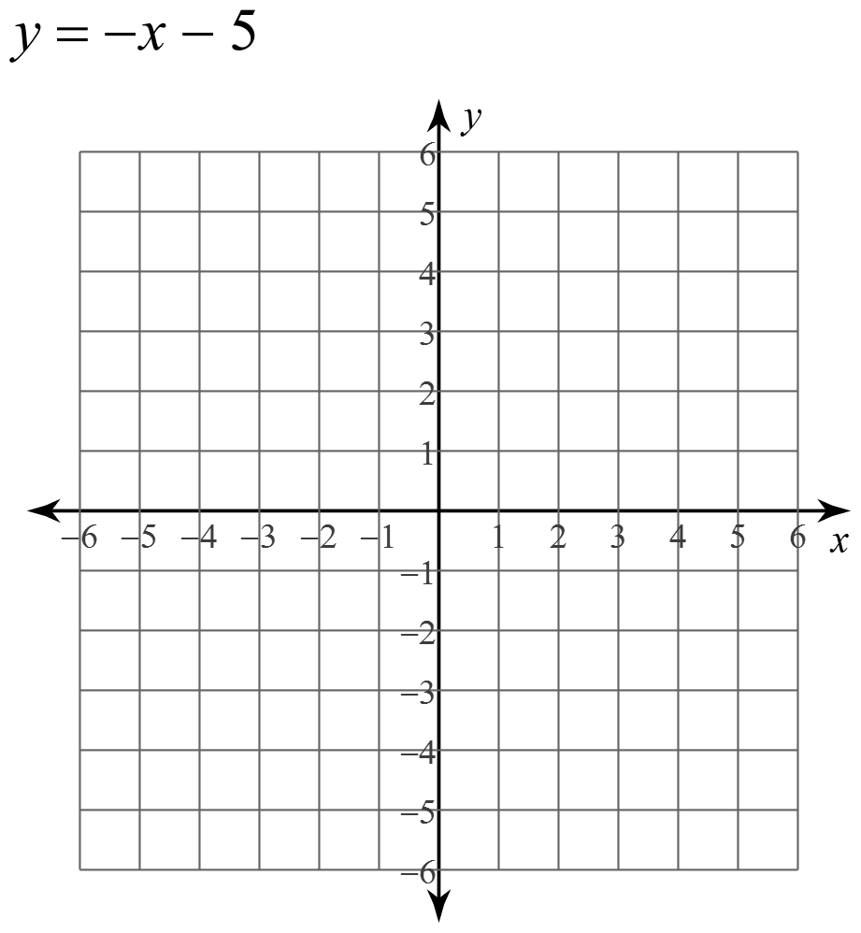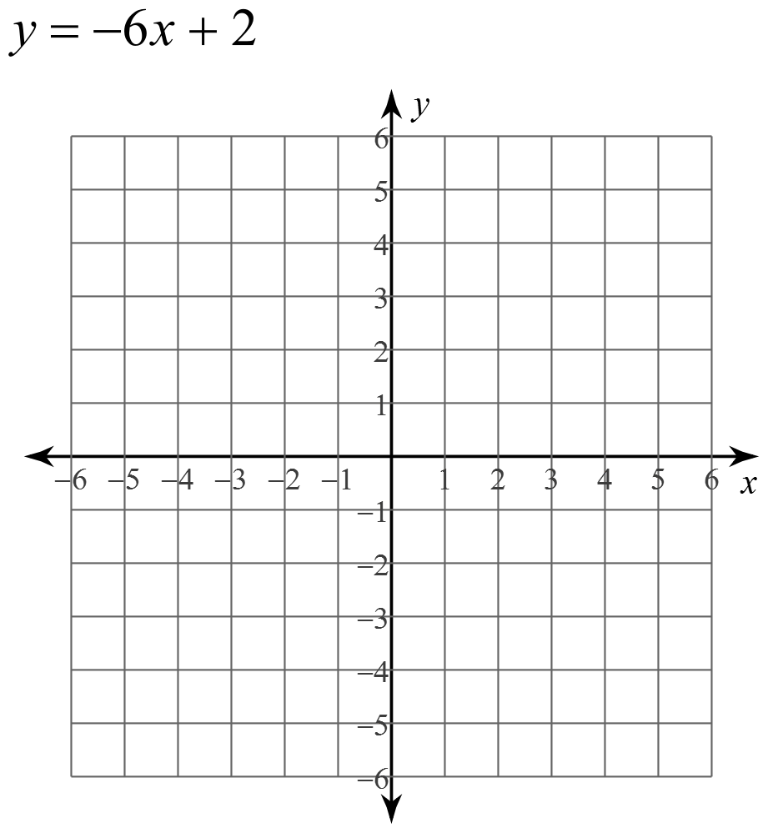

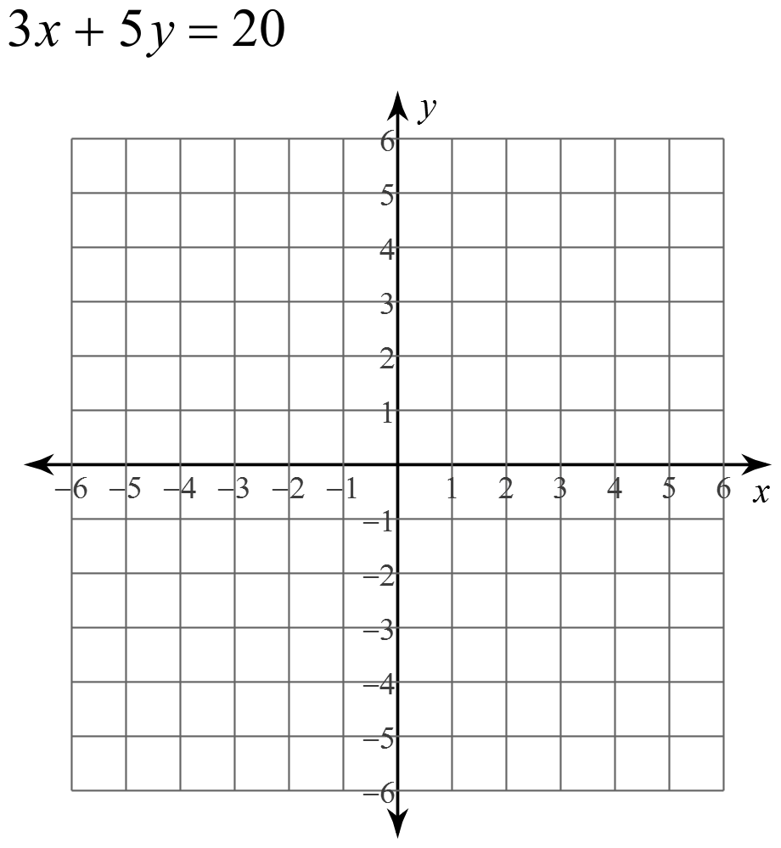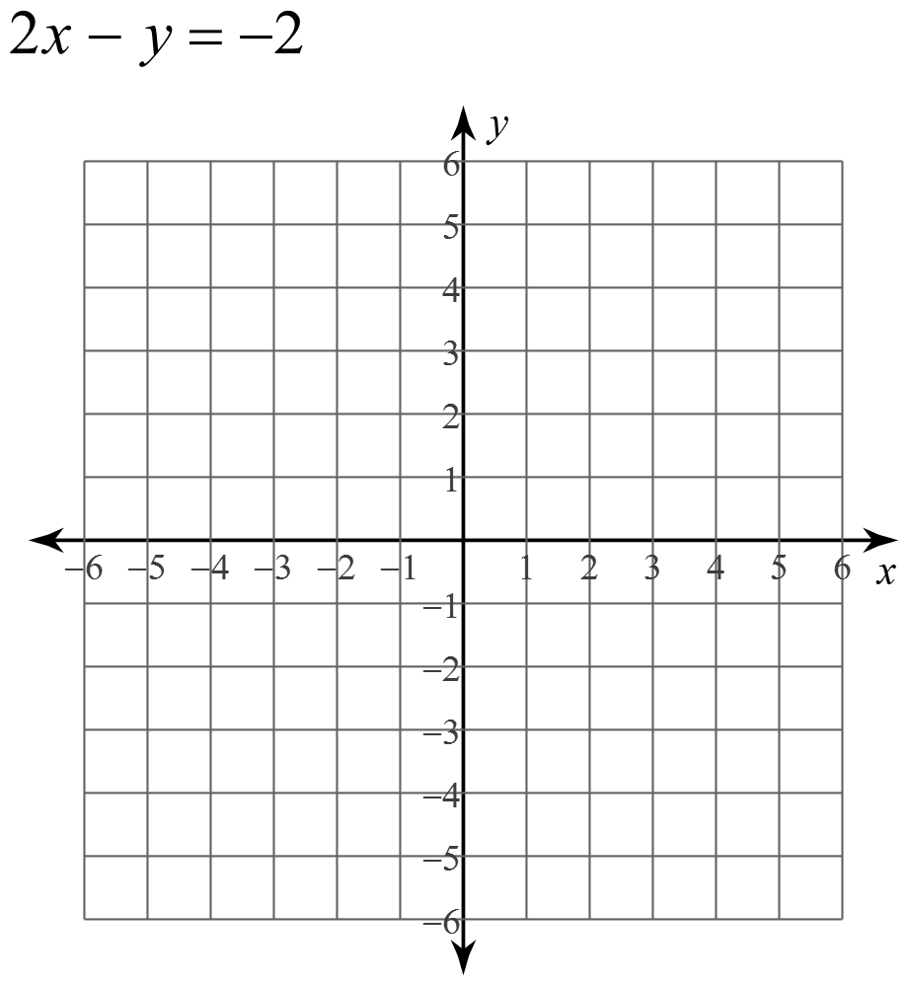

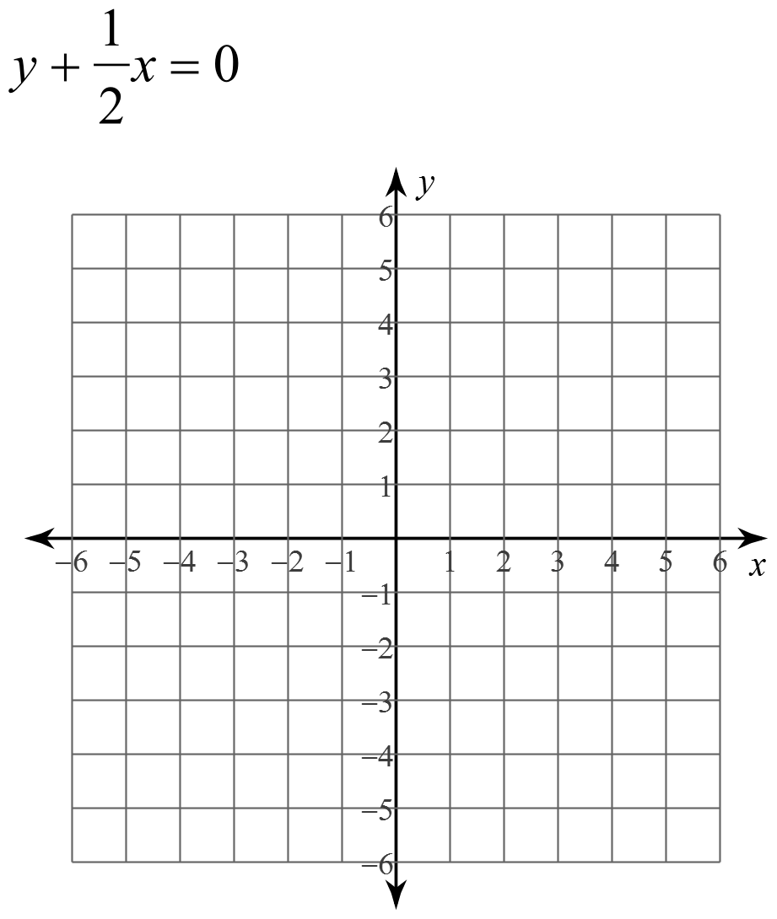

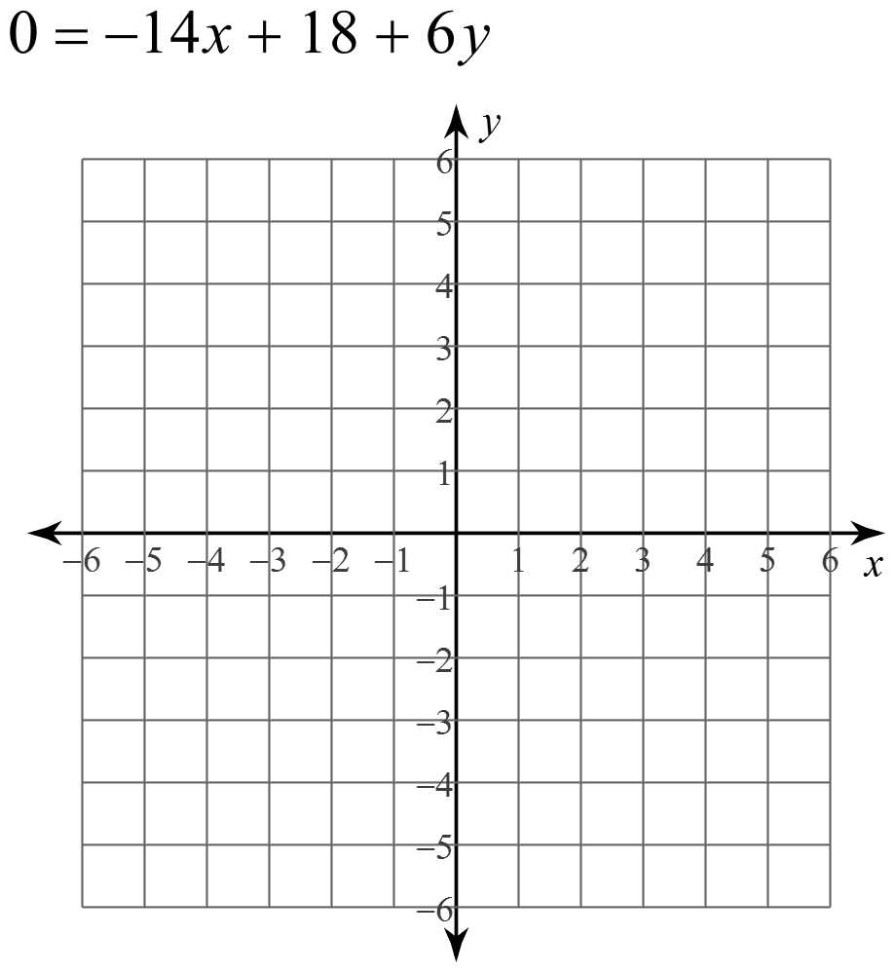

**Success Criteria:**

* I can identify the slope of a line on a graph, or by looking at “m” in the equation *y = mx + b*
* I can identify the y-intercept of a line on a graph, or by looking at “b” in the equation *y = mx + b*
* I can recognize that “y” and “x” in the equation *y = mx + b* are ordered pairs on the graph of a line
* I can write the equation of a line by looking at its graph
* I can graph a line by studying its equation (*y = mx + b*)