**Math 9 – Analytic Geometry**  Name: ____________________

**Lesson #2: Slope Intercept Form (part 2) -- Notes** Date: ______________

**Learning Goal:** We are learning to write the equation of a line without using a graph.

Recall that the slope intercept form is , where *m* is the slope of the line and *b* is the y-intercept. In today’s lesson, we are going to focus on creating the equation of a line given various pieces of information.

**For all the following examples, create** **.**

1.  and  2.  and 

3.  and  4.  and 

5.  and  6.  and 

7. Create the equation of a line which has the same slope as  and has the same y-intercept as .

8. Create the equation of a line which has the same slope as  and has the same y-intercept as .

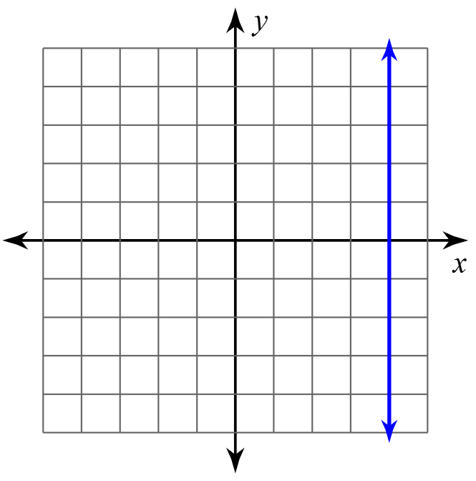**Horizontal and Vertical Lines:** Given the graph, determine the equation of the line:

a) 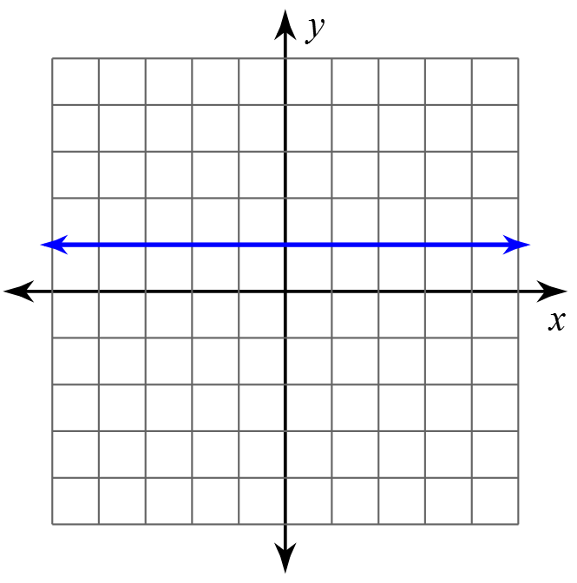 b)

**Success Criteria:**

* I can write the equation of a line if I am given the slope and the y-intercept
* I can find the equation of a line if I am given two ordered pairs by first finding the slope, and then using one of those ordered pairs to find the y-intercept
* I can determine the equation of a vertical and horizontal line