**Math 9 – Analytic Geometry**  Name: ____________________

**Lesson #3: Standard Form – Notes**  Date: ______________

**Learning Goal:** We are learning how to write the equation of a line in standard form by converting it from y-intercept form OR by using the slope-point form.

Today we will explore the second equation of a line form, called the Standard Form. Without further adieu, here it is:.   
 - x and y are

- A, B, and C are

Examples:

Standard Form can also be written as , but then this is called Pseudo-Standard From. We will mostly stick to the true Standard From.

**Example 1: Convert to Standard Form:**

a)  b)  c) 

Standard Form really finds its usefulness when you need to find the x-intercept and the y-intercept.

**Recall:** x-intercept is

y-intercept is

At the x-intercept, y=____. At the y-intercept, x=____. This is true ALWAYS.

**Example 2: Calculate the x-intercept and the y-intercept. Then plot them and draw a line.**

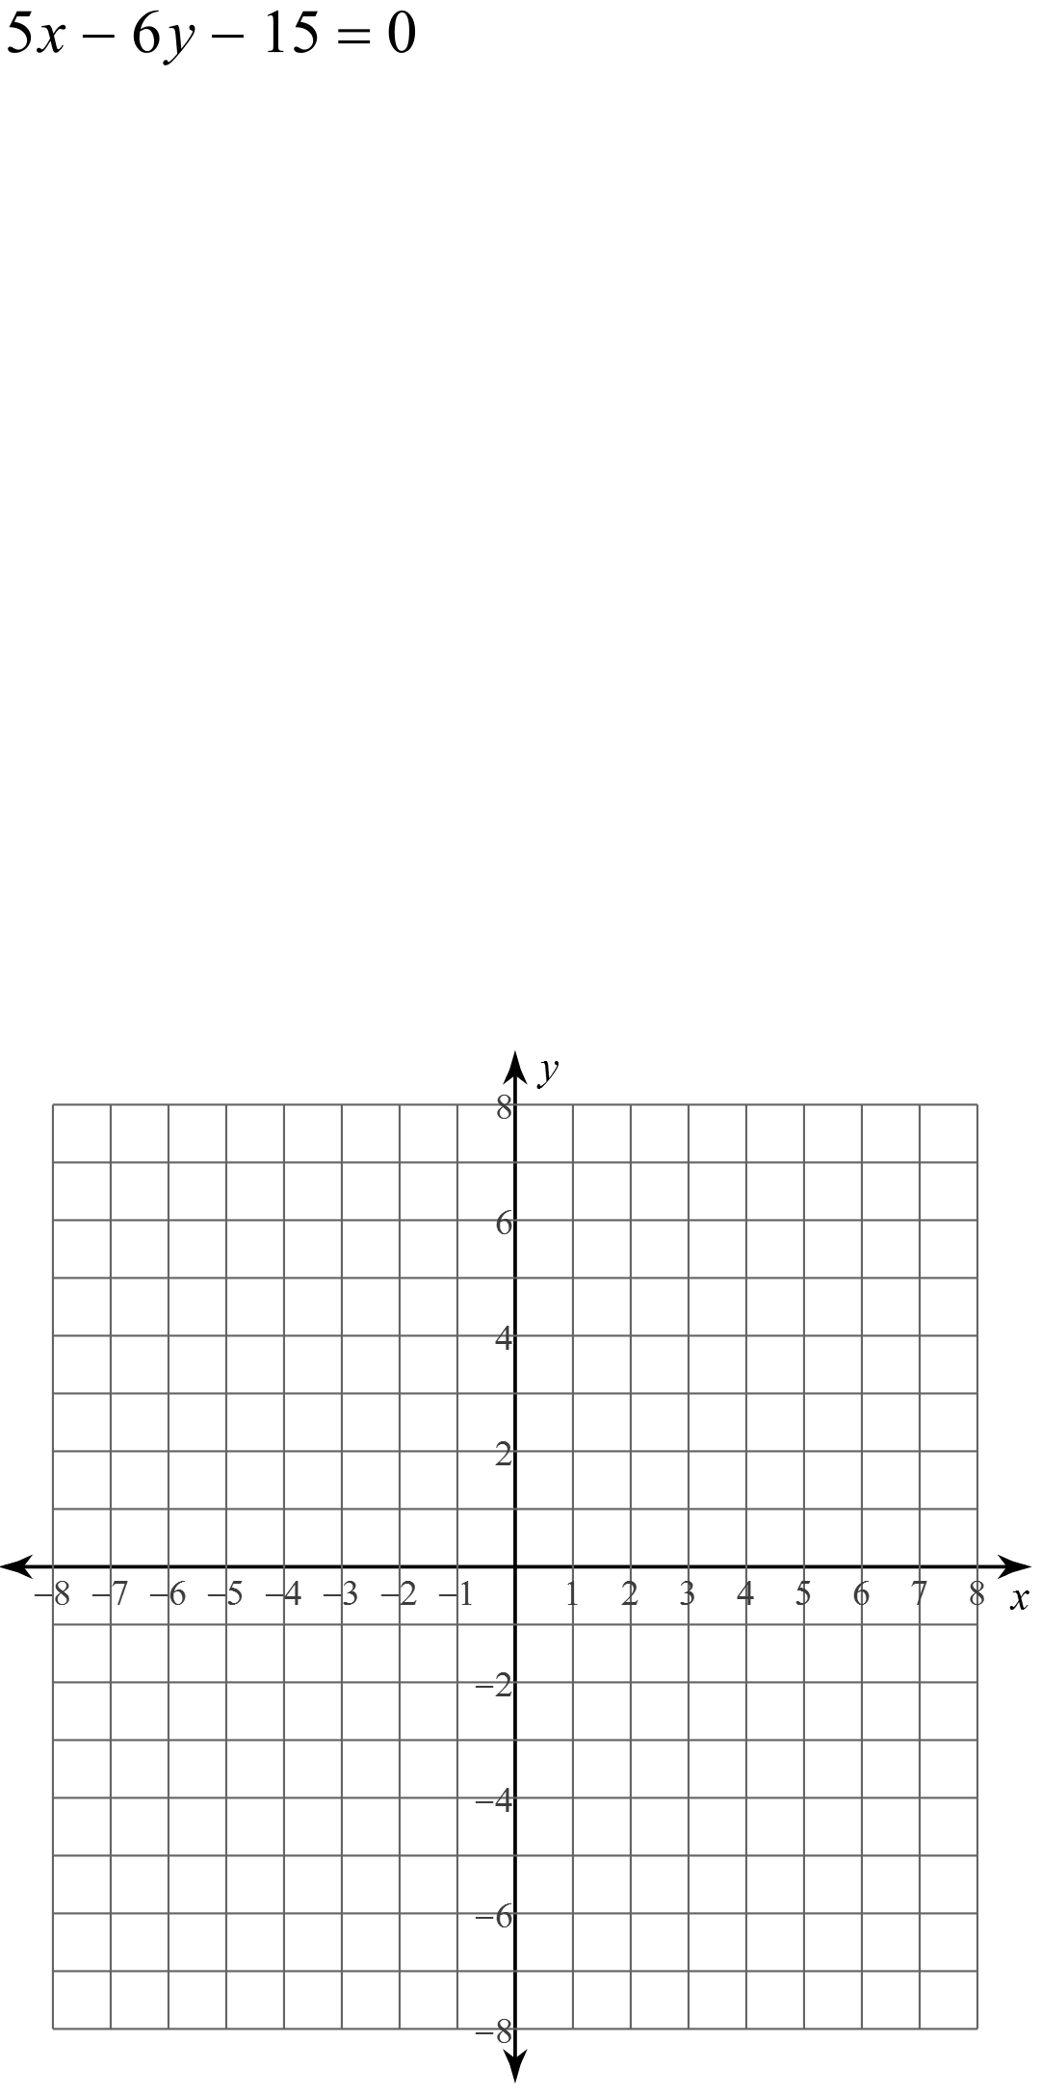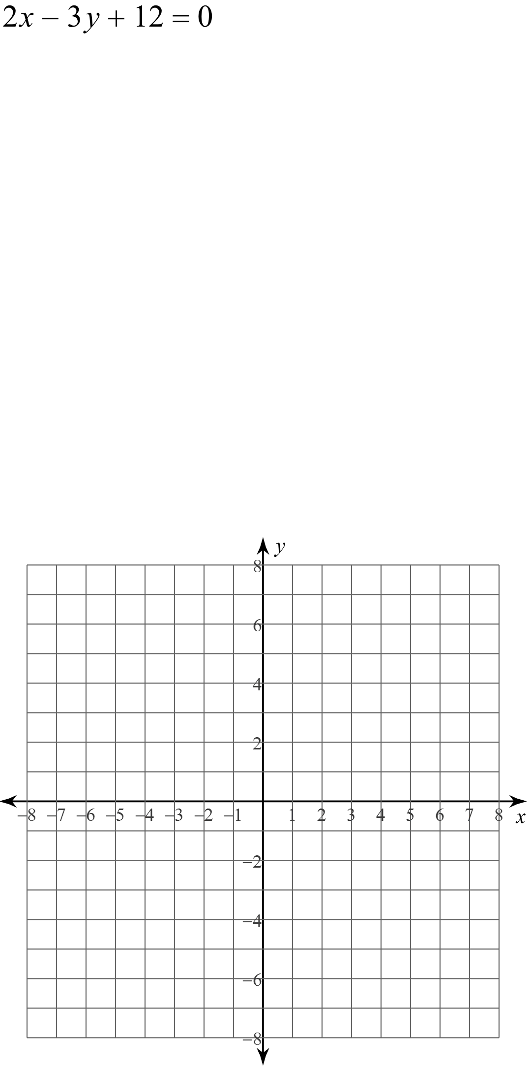a) b)

Just like we did with the Slope Intercept Form (), we learned how to convert to it and how to access some properties to graph. The last thing we need to learn, then, is how to create the Standard Form equation from a graph or from information. This process is a little more tricky, and to help, we need to employ another equation called the *Point Slope Form* is  where m is slope and  is the given point. This form comes from the slope formula.

**Example 3: Create the Standard form given the following information.**a)  and 

b)  and  c)  and 

d)  and  e)  and 

**Success Criteria:**

* I can convert the y-intercept form into standard form by expanding it and collecting like terms
* I can write the equation of a line in standard form by using the point-slope formula
* I can find the y-intercept of a line by setting x = 0 in the standard form equation
* I can find the x-intercept of a line by setting y = 0 in the standard form equation
* I can graph a line, if I am given its equation in standard form, by finding the x and y intercepts