**Math 9 – Analytic Geometry**  Name: ____________________

**Lesson #4: Intersecting Lines – Notes**  Date: ______________

**Learning Goal:** We are learning to find the Point of Intersection of two lines by graphing them.

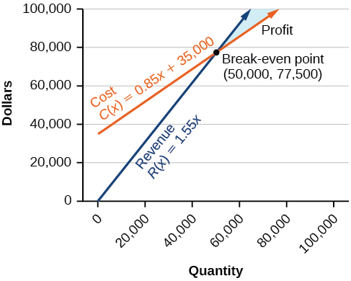“One is fun, but two is even better…” goes a song in one of my daughter’s books. Today, we will look at graphing two lines on the same grid to find the point where the lines intersect. Why is this important? Well, at this point (no pun intended), you are just learning the math behind lines. In Grade 10, you will begin by taking a deeper look into lines with Systems of Linear Equations and Analytic Geometry (and yes, they are more exciting than they sound). Let’s say that you are working for a company coming up with a new product. You work out the revenue equation (how much money is earned) and the cost equation (how much is spent). You need to figure out when those two lines meet to get to the break-even point (when you gain just as much as you spend). Everything after that is profit. From this, you can decide to sell your product for more, for less, or maybe you need to look at some ways to save costs. That break-even point is called the Point of Intersection (PoI). In this lesson, we will learn how to find the PoI by graphing.

**Example 1. Graph both lines, then state the Point of Intersection.**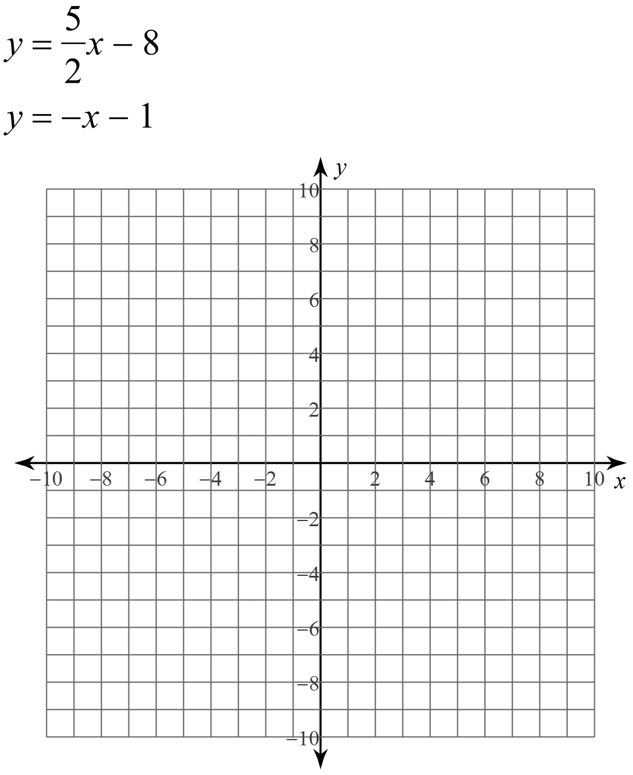

**Example 2: Graph both lines by finding the x-intercept and y-intercept. Then state the PoI.**

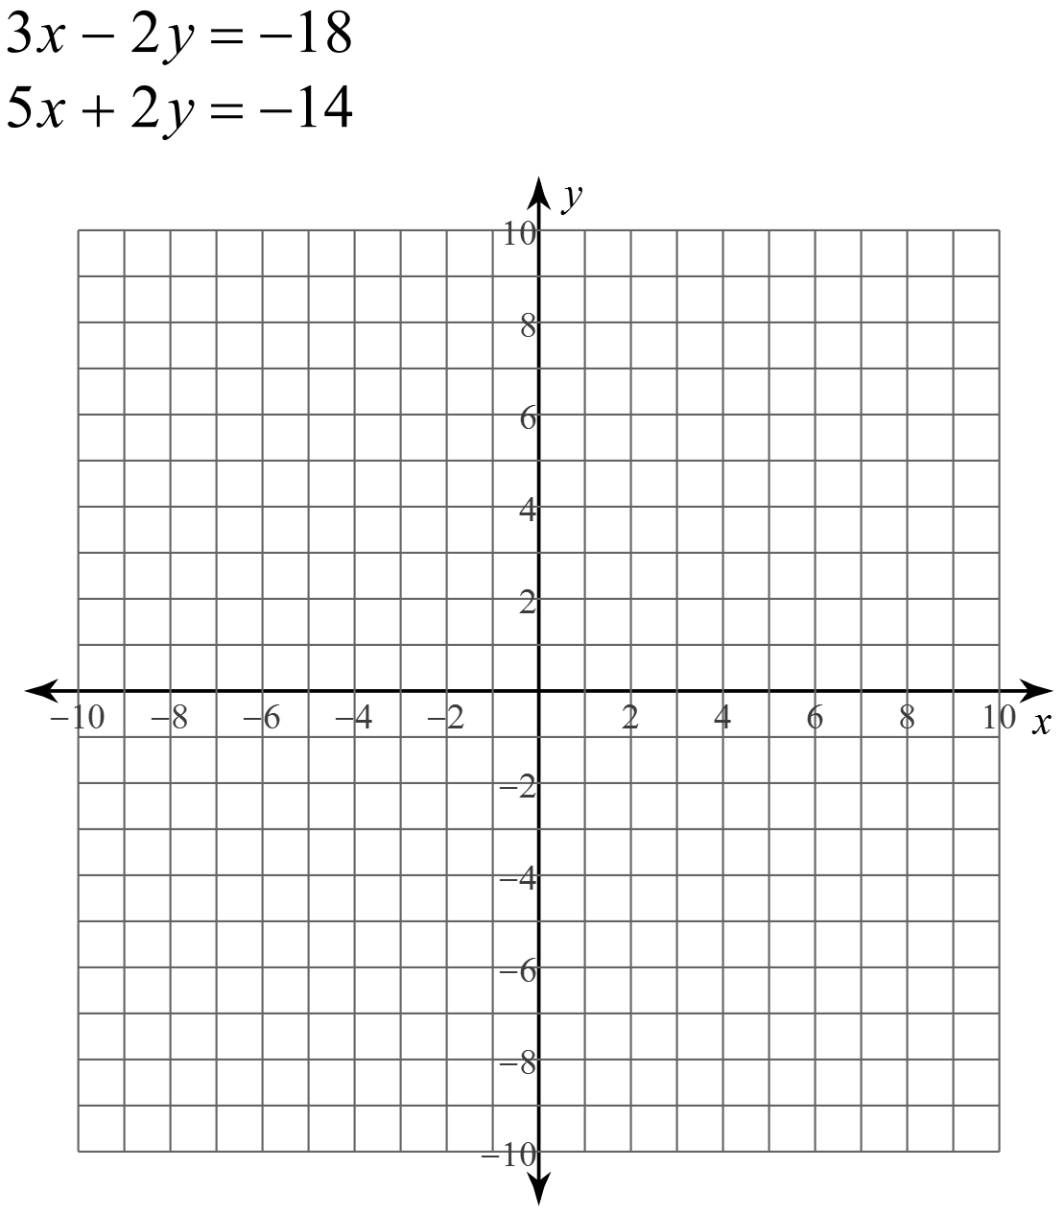

**Success Criteria:**

* I can find the POI of two lines by graphing them
* I can draw the graph of a line if I am given its equation in either y-intercept or standard form