**Math 9 – Analytic Geometry**  Name: ____________________

**Lesson #5: Parallel and Perpendicular Slopes – Notes**  Date: ______________

**Learning Goal:** We are learning the properties of parallel and perpendicular lines.

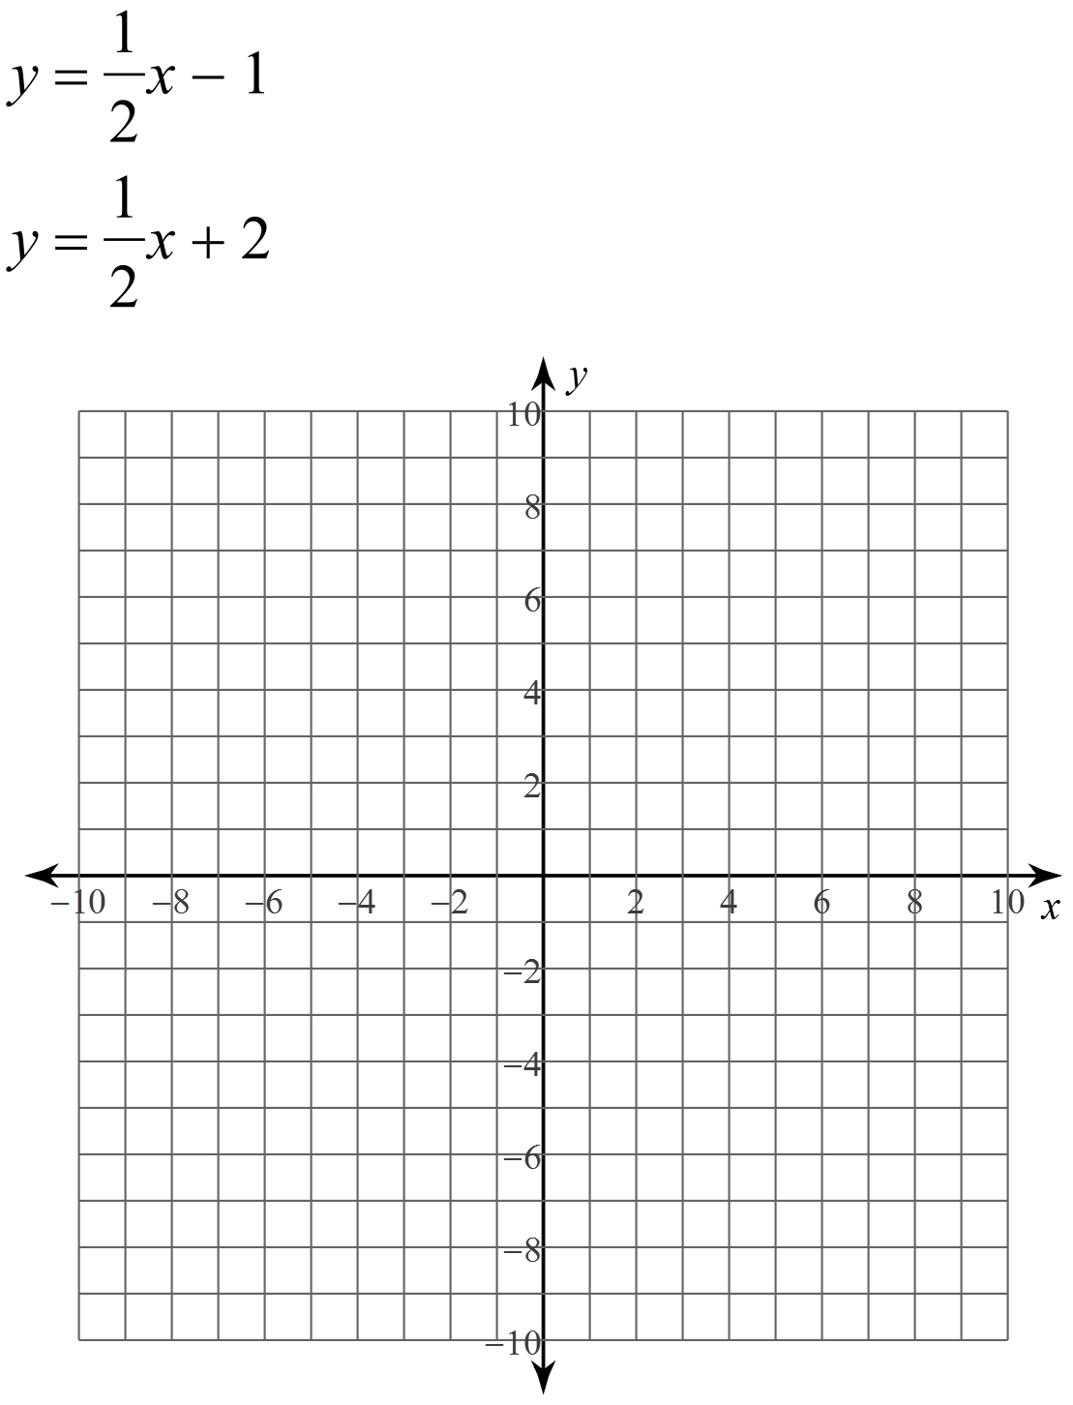Graph the following two lines on the same grid.

These lines are _______________, meaning that their ___________ are __________. In fact, if you have two equations and you want to know if they are parallel, just find their slopes.

**Example: Determine the slopes of each line to determine if they are parallel or not.**

**a)  b) **

** **

Now, graph these two lines on the same grid.

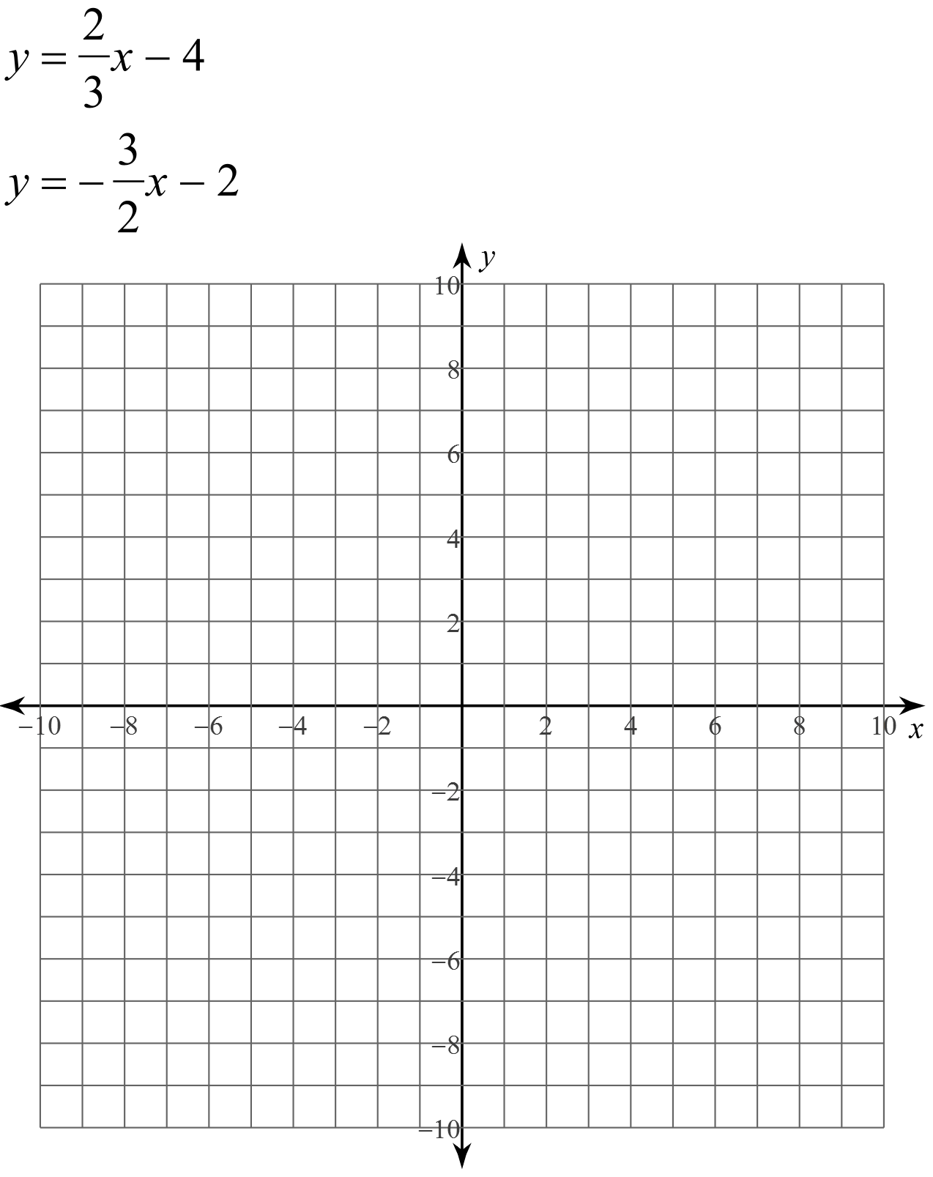

This time, the lines do intersect. However, it is not the point of intersection that is important, it is the angle at which these lines are intersecting each other which is important. These lines are crossing at a _____ degree angle. We call these lines ______________________. Just with parallel lines, it is the slopes that help us determine whether lines are __________________________.

The slope of the first line is: The slope of the second line is:

These slopes are called the negative reciprocal of each other. This means that one slope is negative and one slope is positive. Reciprocal means that the fraction is flipped around.

In general terms, we write:

**Example: Determine the slope perpendicular to the given slope:**

a)  b)  c)  d) 

Now for the big questions. The goal of these questions is to create an equation with properties taken from other equations. Remember, to create an equation of a line, we need a slope and a point.

1. Create a line in Standard Form which is parallel to  and has the same x-intercept as .

2. Create a line in slope-intercept form which is perpendicular to  and goes through the point (6,1).

3. Create a line in Slope-Intercept Form that has the same y-intercept as  and is parallel to .

4. Create a line in Standard Form that is perpendicular to the slope formed by the points (5,2) and (-1,8) and goes through the origin.

**Success Criteria:**

* I can determine if two lines are parallel by seeing if they have the same slope
* I can recognize that parallel lines have different y-intercepts
* I can determine if two lines are perpendicular by seeing if their slopes are negative reciprocals of each other
* I can create a new equation based certain conditions