**Math 9 – Plane Geometry**  Name: ____________________

**Lesson #1: Angles**  Date: _____________________

**Learning Goal:** We are learning to identify types of angles and to use angle theorems to find unknown angles.

In Plane Geometry, we are going to look at angles, triangles, and parallel lines. Within each of these, we are going to define and analyze different theorems which are statements of truth within Plane Geometry. Much of this could be review for you. Please ensure that you are also practicing and reviewing for the exam.

First, let’s draw and define the 5 different types of angles.

1. **Acute** 2. **Right** 3.  **Obtuse**

4. **Straight** 5. **Reflex**

In this lesson, there are three theorems that we will explore. When you are solving questions, you must do two things. The first is to give an answer. The second is to state the theorem that you enacted to validate your solution.

1. **Supplementary Angle Theorem (SAT)** 2. **Complementary Angle Theorem (CAT)**

3. **Opposite Angle Theorem (OAT)**

**Classify each angle as acute, obtuse, right, or straight.**

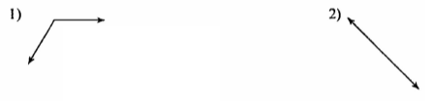

**Name the relationship: complementary, supplementary, or opposite.**

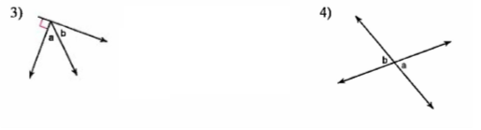

**Find the measure of angle b.**

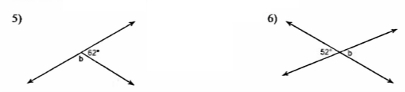

**Find the value of x. First state the theorem that you are using.**

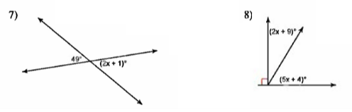

**Success Criteria:**

* I can identify acute, right, obtuse, straight, and reflex angles
* I can identify the SAT, CAT, and OAT Theorems
* I can use the three theorems to find the value of an unknown angle