**Math 9 – Plane Geometry**  Name: ____________________

**Lesson #2: Triangles**  Date: _____________________

**Learning Goal:** We are learning to identify 6 types of triangles and 3 triangle theorems. We are learning to use those theorems to find missing information in triangles.

Did you know that the strongest shape is the triangle? Triangles are also amazing within Mathematics. In Grade 10 and beyond, you will begin to learn about Trigonometry, which is a study of the relations between the angles and sides of a triangle. Today, we will look at the properties of angles within a triangle. First, let’s review the six types of triangles:

**1. Scalene 2. Isosceles 3. Equilateral**

**4. Acute 5. Right 6. Obtuse**

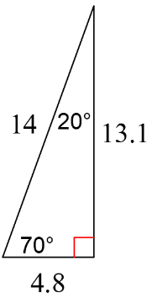**Example 1: Classify each triangle with its sides and angles.**

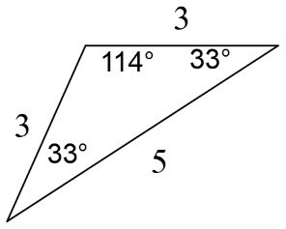a) b)

**Triangle Theorems:** Just like last lesson, triangles have properties which are truths, and therefore we can call them theorems which help us to solve for missing information.

**1. Isosceles Triangle Theorem (ITT)**

**2. Angle Sum Triangle Theorem (ASTT)**

In fact, the angles in a quadrilateral add up to ______. In a 5-sided figure, the angles add up to _____. When you add a side, you add ______ to the sum of the angles.

**3. Exterior Angle Theorem (EAT)**

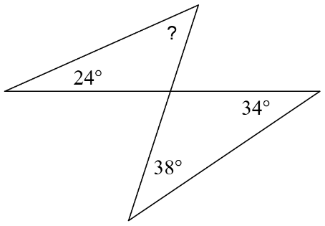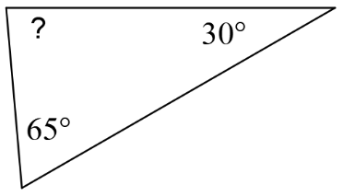**Example 2: Find the missing angle (?) or the value of x. State the theorems you are using on each step.**

a) b)

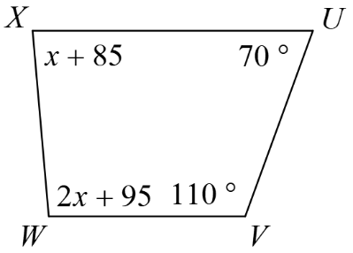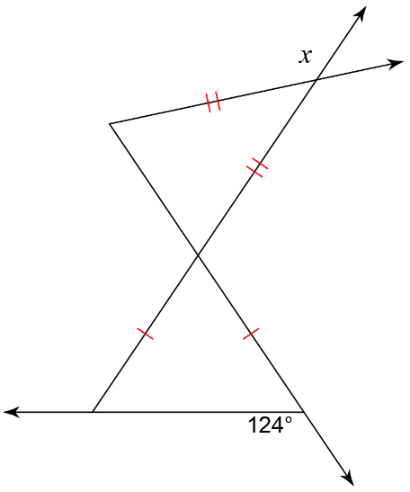c)d)

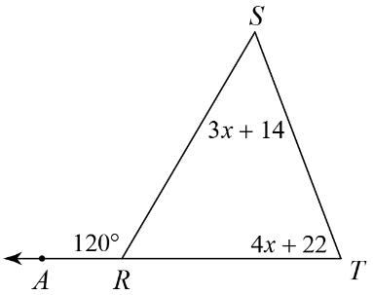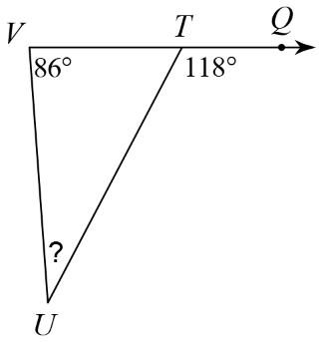

e) f)

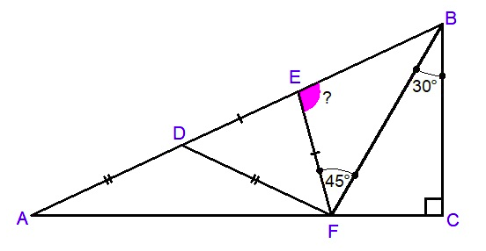g) Tricky one. Try it out!

**Success Criteria:**

* I can identify scalene, isosceles, equilateral, acute, right, and obtuse triangles
* I can identify the ITT, ASTT, and EAT triangle theorems
* I can use the 3 triangle theorems and the 3 angle theorems from yesterday to find missing information in a triangle (or group of triangles)