**Math 9 – Plane Geometry**  Name: ____________________

**Lesson #3: Parallel Lines**  Date: _____________________

**Learning Goal:** We are learning to identify angles that are based on two parallel lines intersected by a third line. We are learning to use these rules to find unknown angles.

In our final lesson of the year (yikes), we will look at the properties of two parallel lines intersected by a third line. There are three theorems, or patterns, that exist within two parallel lines. Keep in mind the theorems of SAT and OAT in this lesson.

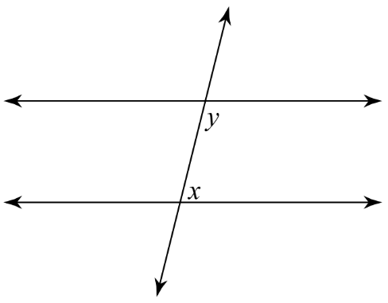**1. Alternate Angles 2. Co-interior Angles**

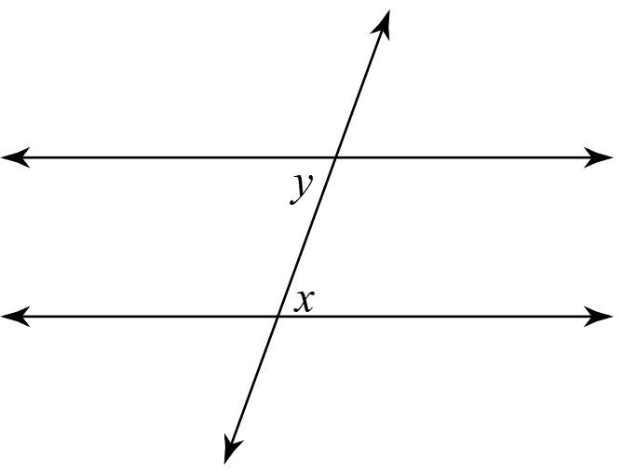

**3. Corresponding Angles**

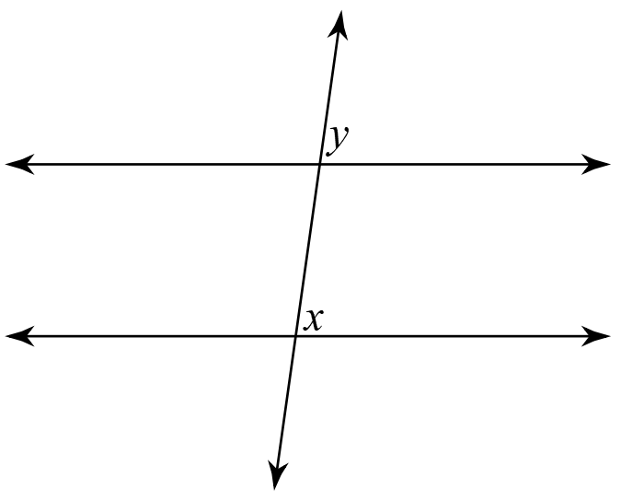

**Example 1:** Find the measure of the indicated angle (?). State your reasoning.

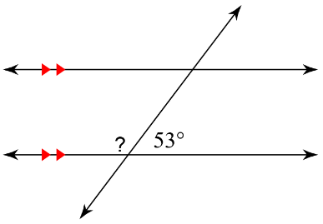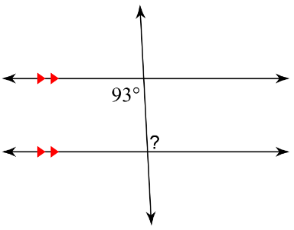a) b)

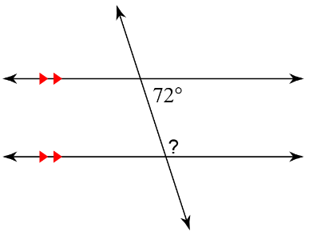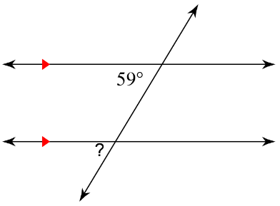c) d)

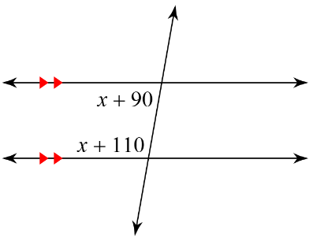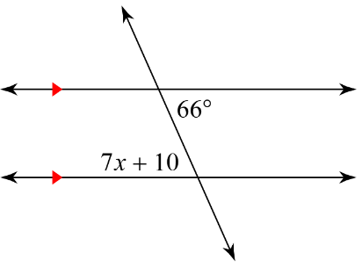**Example 2:** Determine the value of *x*. State your reasonings.

a) b)

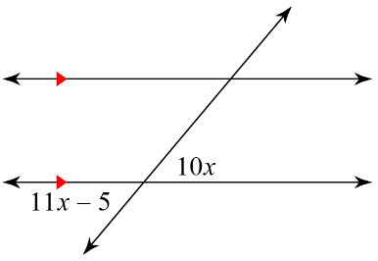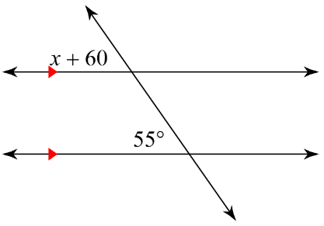

c) d)

**Success Criteria**

* I can identify the Z, C, and F patterns in parallel lines intersected by a third line
* I can use these patterns to identify the values of unknown angles